AR Table of Contents
AR Table of Contents 1
Icons 3
AR Icons Overview 3
Operations 4
AR Overview 4
Accounts Receivable Main Menu 5
Simple Invoice Entry 7
Simple Invoice Printing 11
Simple Invoice Register 14
Cash Receipts Entry 17
Cash Receipts Register 26
Aging Report 30
Aging Analysis Report 34
Age Accounts Receivable Transactions 39
Accounts Receivable Reports 41
Customer Label Printing 42
Customer Name Listing 46
Customer Detail Listing 49
Customer Comments Listing 53
Customer Name and Address Listing 56
Customer Ledger Card Listing 59
Period-End Processing 62
Aging Report 63
Generate Finance Charges 63
Finance Charge Entry 66
Purge Finance Charge Entries 68
Finance Charge Register 69
Customer Statements 72
Monthly Cash Receipts Journal 75
Monthly Cash Receipts Journal Purge 78
Customer Ranking Report 81
Period-End Update 84
Accounts Receivable Maintenance 86
Customer Maintenance 88
Customer Type Maintenance 111
Salesperson Maintenance 112
Terms Code Maintenance 113
Tax Code Maintenance 115
Freight Terms Code 118
Territory Code Maintenance 120
Distribution Code Maintenance 121
Standard Message Header 124
Customer Price Code 125
Sale Discount Code 126
Cash Receipts Code Maintenance 127
Cycle Code Maintenance 131
Accounts Receivable Parameter Maintenance 132
Application Parameters 133
Report Parameters 135
New Customer Defaults 138
Credit Management Parameters 139
Accounts Receivable Utilities 142
Conversion Invoice Entry 143
Conversion Invoice Register 145
Invoice Date Modification Entry 148
Invoice Date Modification Register 150

Icons

AR Icons Overview

The following navigation and operation icons are used throughout this documentation. Refer to this list for descriptions and keyboard equivalents.

 | New – clears the current form in order to enter new data. | Ctrl+N
 | Add to end – used in grid entry to add a new record after the last current row. | Ctrl+A
 | Insert before – used in grid entry to insert a new record before the currently selected row. | Ctrl+Shift+A
 | Delete current record – if focused in header portion of header/detail form, prompts for deletion of header and all detail; if focused in a detail grid, deletes current row. | Alt+Del
 | Save current record – saves current record in a grid, or header and all detail records if in a header/detail form. | Ctrl+S
 | Refresh data – refreshes current display. | Alt+F5
 | Run process – used in Options Entry forms after selections have been made to run the associated program. | F5
 | Print current record – prints the currently displayed record to the Document Output window | Ctrl+P
 | First record – navigates to the first record in a table when in Maintenance Grid mode. | Alt+Page Up
 | Previous record - navigates to the previous record in a table when in Maintenance Grid mode. | Page Up
 | Next record - navigates to the next record in a table when in Maintenance Grid mode. | Page Down
 | Last record – navigates to the last record in a table when in Maintenance Grid mode. | Alt+Page Down
 | Record Query - Invokes the inquiry subsystem to view records from the table associated with a form. | Ctrl+Q
 | Find – used to display a list of candidate records when in a validated field. | Ctrl+F
 | Expand record – used to display full contents of the record underlying a validated field. | Ctrl+E
 | Calendar – launches a graphical calendar for use in date fields. | Ctrl+L
 | Launch link – launches the specified URL
 | Drilldown – launches a user-specified drilldown definition. | Ctrl+D
 | Options – dropdown menu containing optional processes, such as subsidiary forms or reports. | Ctrl+O
 | Close – closes the active window. | Ctrl+F4

Operations

AR Overview
The Accounts Receivable Operations section contains a description of all Accounts Receivable tasks. For each task, a sample screen is shown followed by a description of each field and an explanation on how the task operates. Additionally, an example of all reports and registers is provided in Appendix A. This section can be used as a reference when using any of the Accounts Receivable tasks. Refer to the AddonSoftware Administrator manual for basic operating instructions on how to select a task or how to move about a screen.

A complete understanding of the Accounts Receivable module is easier if the Introduction, Installation and Flow of Processing sections are studied in conjunction with the Operations section. Because the Accounts Receivable module is integrated closely with the Order/Invoice Processing and Sales Analysis modules, many of the features described here are more meaningful when used in conjunction with those modules.

The tasks shown here are organized according to how they appear on the menu in a standard installation of the software. Because the AddonSoftware menu system permits customization of the description and organization of the menus, your system may vary slightly from the information presented here.

Accounts Receivable Main Menu
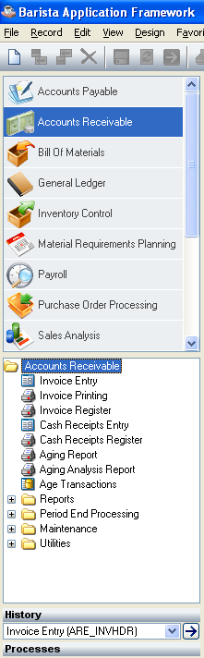

Accounts Receivable Main Menu

Function
The Accounts Receivable main menu provides access to most tasks in the Accounts Receivable module, including the Period-End Processing and Accounts Receivable Maintenance menu.

n To access Accounts Receivable...

Select Accounts Receivable from the AddonSoftware Menu Options.

Simple Invoice Entry
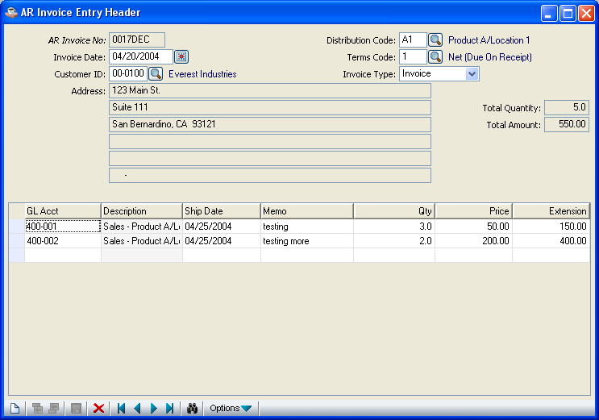
Simple Invoice Entry

Function
The Simple Invoice Entry task provides simple invoicing functions in the Accounts Receivable module when billing integrated with the Inventory Control module is not required. Detailed line items may be entered in the body of the invoice, each having a separate general ledger revenue account, service date, description, quantity, price and extension. Invoices may be printed on plain paper (8-1/2 by 11”) without special forms.

n To access Simple Invoice Entry...

Select Invoice Entry from the Accounts Receivable processing menu.

About the Fields

In the Invoice No field...
• Press Enter to use the next sequential invoice number assigned by the system, or enter a seven-digit invoice number.
- Press the Record Query button to select an existing invoice number.
- Click the Close Window button to return to the Accounts Receivable main menu.

When the invoice number already exists but has not yet been updated, the invoice heading information is displayed. The invoice can be added to, modified or deleted.

In the Invoice Date field...
• Click the Calendar button to enter the date of the invoice.

This date is used to specify the general ledger posting date for the invoice.

In the Customer Number field...
• Enter a valid customer number. (Refer to Accounts Receivable Customer Maintenance.)
- Click the Find button to select from a list of all valid customer numbers.
- If the invoice number has already been updated for this customer, the system will flag it as an adjustment.

In the Name field...
Display only. Shows the name of the customer associated with the customer number.

In the Address field...
Display only. Shows the address of the customer associated with the customer number.

In the City field...
Display only. Shows the name of the city associated with the customer.

In the State field...
Display only. Shows the state associated with the customer.

In the Zip/Postal field...
Display only. Shows the zip/postal code associated with the customer address.

In the Distribution Code field...
• Enter a valid distribution code.

- Click the Find button to select from a list of all valid codes.

This code is used to specify the Accounts Receivable account when the invoice is updated and postings to the general ledger are created. (Refer to Distribution Code Maintenance task in the Accounts Receivable Maintenance section for additional information.) The description of the distribution code is displayed.

In the Terms Code field...
• Enter a valid terms code for the invoice. (Refer to Accounts Receivable Terms Code Maintenance.)
- Click the Find button to select from a list of all valid codes.

The description of the terms code is displayed.

In the Total Quantity field…
Display only. Shows the total quantity associated with this invoice.

In the Total Amount field…
Display only. Shows the total amount associated with this invoice.

In the Invoice Type field…
- Select Invoice if this is a new invoice
- Select Adjustment if this is an adjustment to an existing (updated) invoice
- Select void to record an invoice number that will not be used. Note that an invoice posted to this customer can not be voided; it must be adjusted to zero.

Invoice Detail Section

In the GL Account field...
When the General Ledger is installed:
• Enter a valid general ledger account number that (usually) represents the revenue posting account for this detail line.

The description of the account number is displayed.

In the Ship Date field...
• Enter the date of service or delivery of the product.
This date has no effect on the general ledger posting for the invoice.

In the Memo field...
• Enter a description of up to thirty characters to describe the product or service identified by the line. This memo will be the detail that will print on the invoice.

In the Qty field...
Optional
• Enter the quantity for the invoice detail line, if applicable. The default is zero.

Example
Enter the number of hours if this is a labor charge that is billed per hour.

In the Price field...
Optional
• Enter the price per unit for the invoice detail line, if applicable. The default is zero.

Example
Enter the price per hour when it represents a labor charge that is billed by the hour.

In the Extension field...
This field shows the product of the Qty and Price fields.

- Click Add to end button to enter other invoice detail lines after the last existing line
- Press the Insert Before button to insert a detail line before an existing line.
- Press the Delete Current Record button to remove the line.

When you have finished making invoice entries,
- Click the Save button to save the invoice details. The form is cleared in preparation for a new entry.
- Click the New button to begin a new invoice.

If you attempt to leave an unsaved invoice by clicking New button, the module will issue a confirmation box as follows:

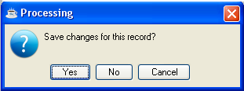

• Click Yes to save the current record and return to AR Invoice Number field in the screen.
- Click No to return to the AR Invoice Number field without saving the current record.

- Click Cancel to return to the current AR Invoice Entry Header Screen.
- Click option button to recalculate the total of all quantities and extensions for the invoice.

Simple Invoice Printing
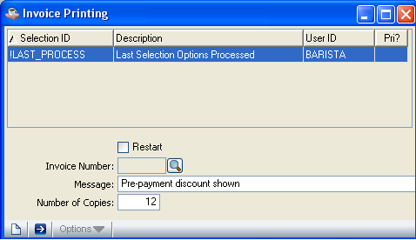

Simple Invoice Printing

Function
All entered invoices are printed through Simple Invoice Entry. This task allows you to restart from a selected invoice and prints on 8-1/2 by 11” continuous paper. Special forms are not required.

n To access the Simple Invoice Printing task...

Select Invoice Printing from the Accounts Receivable processing menu.

About the Fields

In the Restart field...
• Check Restart box to restart the invoice printing beginning with a specific invoice number.

- Uncheck Restart box to start printing from the first invoice number (this is the normal option).

- Click the Close Window button to return to the menu.

NOTE: The restart option is only used in the event of a paper jam or a torn invoice.

In the Invoice Number field...
• Enter a valid invoice number to restart printing.

This option is only used when the Restart box is checked .

In the Message field...
Optional
• Enter a general message of up to thirty characters in length to be printed at the bottom of each invoice.

Example
Messages announcing changes in company policies or special events can be printed on all invoices.

In the Number of Copies field...
• Enter the number of copies you want to print for each invoice.

This option is valuable when you require more than one printed copy.

The following prompt is issued:

• Click the Run Process button to print the invoices.
- Click the New button to begin a new invoice printing.

If you attempt to leave an unsaved invoice printing by clicking New button, the module will issue a confirmation box as follows:
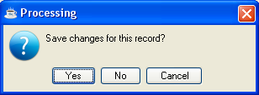

- Click Yes,to proceed with Invoice Printing
- Click No to return to the Restart field without printing .
- Click Cancel to return to the current invoice printing screen.

Printing
As the invoices print, “Invoice Printing” is displayed on the progress bar to indicate the progress of the printing.

Simple Invoice Register
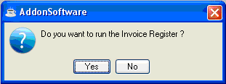
Simple Invoice Register

Function
The Simple Invoice Register prints a register of all invoices entered through Simple Invoice Entry (including voided invoices). There are no entry fields with this task. The register begins printing as soon as you respond affirmatively to the prompt.

n To access the Simple Invoice Register...

Select Invoice Register from the Accounts Receivable processing menu.

The prompt issued reads:

- Click Yes to print the register.

- Click No to return to the menu without printing.

Printing
As the invoices print, “Invoice Register” is displayed on the progress bar to indicate the progress of the printing.
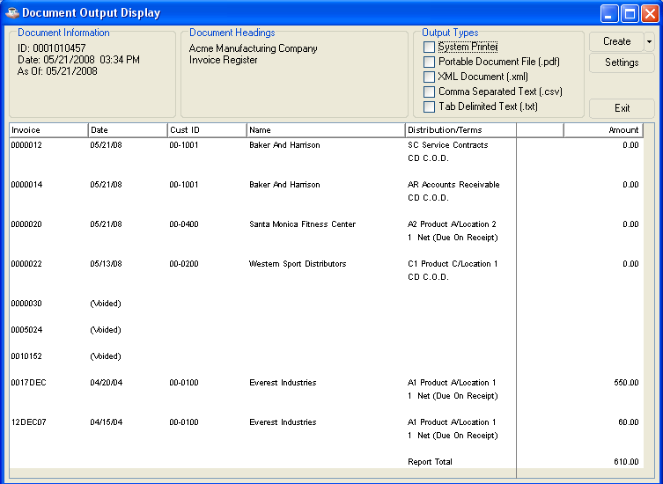
Once the register is printed, the following prompt is issued:

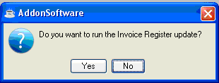

• Click Yes to update the invoices.
- Click No to return to the menu without updating.

NOTE: If you do not update the register at this time it is necessary for you to run the register again in order to update the invoices on this register.

Updating
The act of updating posts the total of each invoice to the accounts receivable open invoice file. Prompt payment discount amounts and due dates are calculated based on the terms code associated with each invoice. The update also posts the extension amount from each invoice detail line to the general ledger account defined for each line. The offset posting for the total of all invoice detail line amounts is made to the receivables account defined by the distribution code associated with each invoice. As each invoice is updated, the progress bar indicates the progress of the update.

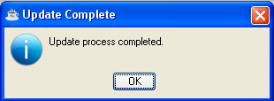

Cash Receipts Entry
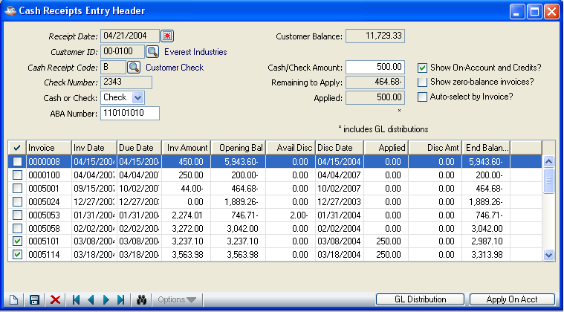
Cash Receipts Entry

Function
The Cash Receipts Entry task allows entry of payments and adjustments to a customer’s account. The heading section defines the customer, date and transaction information. Once the heading information has been entered, this task has two separate displays that allow invoice entry or general ledger postings.

The AR Distribution display allows application of payments and credits to invoices and on-account. The GL Distribution display allows posting of miscellaneous transactions directly to general ledger accounts.

n To access the Cash Receipts Entry...

Select Cash Receipts Entry from the Accounts Receivable processing menu.

About the Fields

NOTE: GL Distribution displays when pressing the button of GL Distribution in Cash Receipts Entry Header.

Customer Information

In the Receipt Date field...
• Click the Calendar button to enter the date that the receipt is posted to the general ledger.
- Click the Close Window button to return to the Accounts Receivable Main Menu.

The Cash Receipts Register is sorted by Receipt Date to allow you to associate receipt transactions with their corresponding general ledger postings. The Receipt Date is also used to determine whether or not a discount has expired for a particular invoice. Because the Receipt Date is also used to identify cash being applied on-account, only one on-account payment may be made per customer per receipt date. Change the Receipt Date field to make subsequent on-account payments for a customer.

In the Customer ID field...
• Enter a valid customer number.

- Click the Find button to select from a list of all valid customers.

In the Name field...
Display only. Shows the name of the customer whose number you entered in the Customer Number field.

In the Cash Rec Code field...
• Enter a valid three-character cash receipts code.

- Click the Find button to select from a list of all valid codes.

The description of the code is displayed. This code is used to determine the cash account in the general ledger and parameters that affect the processing. Refer to Cash Receipts Code Maintenance task later in this section.

In the Check No field...
• Enter a check number or any other identifying number.

In the Cash/Check field...
• Select Check to indicate a check.

- Select Cash for a cash transaction.

In the ABA Number field...
Optional
• Enter the bank identification number from the check.

This optional field prints on the Cash Receipts Register and is helpful in preparing the deposit slip.

In the Amount field...
• Enter the amount of cash received.

Adjustments, credit memos and other transfer transactions may not require a cash amount, depending on how the cash receipts code is defined. (Refer to note for Cash Receipt Code.)

In the Applied field…

Display Only. The amount of payment that has been applied to invoice(s).

In the Show On-Account and Credits? field…

• Check On-Account and Credits box to show On-Account and Credits details in the detail section.

In the Zero-balance invoices? field…

• Check Zero-balance invoice box to show zero balance invoices.

In the Auto-select by Invoice? field…

• Check Auto-selection box to show auto selection by invoices.

In the Balance field...
Display only. Shows the balance remaining to be applied to invoices.

NOTE: A cash receipt transaction cannot be completed until this amount is equal to zero, thereby providing a check that your transaction is in balance.

AR Distribution Information

In the Invoice field...
- Enter a valid invoice number for the customer.
- Check On-Account and Credits box to show On-Account and Credits details.
- Check Zero-balance invoice box to show zero balance invoices.
- Check Auto-selection box to show auto selection by invoices
.
Invoices are displayed with the invoice date, due date, current invoice amount and available payment terms discount. An invoice originally created with a terms discount is displayed if the cash receipts date is not after the discount due date.

When selecting individual invoices for payment, entries may be made for each of the following fields:

In the Applied field...
• Enter the amount of cash you want to apply to this invoice.

- Press Enter to apply cash up to the amount of the invoice, less available discount. If the cash is less than the invoice balance, the remaining amount is applied when pressing Return.

In the Discount field...
• Enter the amount of discount to be applied to the invoice.

- Press Enter to apply the available discount shown.

NOTE: The discount amount for an invoice is shown only when the cash receipts date is earlier than the discount expiration date as determined by the terms code associated with the invoice.

In the Balance field...
Display only. The remaining invoice balance is automatically calculated and displayed.

When you finish with the line entries, the following prompt is issued:

• Click the Save button to save the line entries.

- Click the Delete button to remove the line from the Cash Receipts Entry.

Once all entries to the line are accepted, the following prompt is issued:
- Click the Save button to save the cash receipt entry.

- Click GL Distribution Button to move to the GL Distribution display. (Refer to the GL Distribution Information section for more information.)

- Press the New buttonto begin a new cash receipts entry.

If you attempt to leave an unsaved Cash Receipts Entry by clicking New or Close Window, the module will issue a confirmation box as follows:

- Click Yes to save the current record and return to Accounts Receivable Processing Menu.
- Click No to return to the Accounts Receivable Processing Menu without saving the current record.

On-Account Payments
To put a check “on-account”, enter the check information for the customer, and press Apply On-Account. An on-account payment for the full amount of the check is automatically created. An on-account payment will be identified with this structure: OAymmdd, where “OA” stands for on-account, year (ie 8 for 2008), month and day of the payment. An on-account payment posted on October 15, 2008 would be labeled “OA81015”. Only one on-account payment can be created for a specific day.

Applying a Previous On-Account Balance to Open Invoices
When using an existing on-account amount to pay invoices and there are no external funds being received, you should enter zero for the Amount field in the heading. Proceed with data entry as follows:

- Apply payment to invoices in the usual manner. This will cause the Balance field in the heading to accumulate a negative amount if a zero deposit amount was originally entered.

- Check On-Account and Credits box to show On-Account and Credits details.
- Check Zero-balance invoice box to show zero balance invoices.
- Check Auto-selection box to show auto selection by invoices

- Type the on-account invoice number (OAymmdd) in the Invoice field and apply a negative amount to the on-account invoice in the same amount as applied to the invoices that were paid.

An existing on-account amount normally appears as a negative number that indicates a credit to the customer’s account. To use on-account, you apply a matching negative amount. As a result, the Balance field in the header is increased. Apply a positive amount to an invoice to pay it. Balance field changes to zero.

Applying Credit Memos to Open Invoices
When using an existing credit memo amount to pay invoices external funds are not being received, you should enter zero for the Amount field in the heading. Proceed with data entry as follows:

1. Apply payment to open invoices in the usual manner.

2. Call up the credit memo to be applied by entering its number at the Invoice field.

3. Apply a negative amount to the credit memo in the same amount as applied to the invoices that were paid.

Credit amounts normally appear as negative numbers indicating a credit to the customer’s accounts. To use the credit, you apply the matching negative amount. The Balance field in the header is increased as a result.

In a cash receipts transaction where cash is not actually received, the general ledger postings normally created by the application of payment (i.e. Debit to Cash, Credit to Receivables) are offset by the postings created when the credit is applied as payment (i.e. Debit to Receivables, Credit to Cash). The net result is that general ledger postings are not created. This is the desired result as the credit to receivables (and debit to sales) was made at the time the credit memo was originally updated.

GL Distribution Information
In addition to applying payment to individual invoices, the Accounts Receivable module allows you to enter general ledger postings as part of the cash receipts process. Press GL Distribution Button to activate this function.
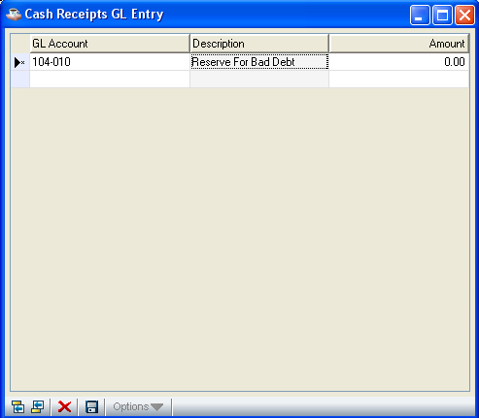

NOTE: GL Distribution is a parameter that is set when defining cash receipts codes. Refer to the Cash Receipts Codes Maintenance later in this section.

General ledger postings allow you to apply a remaining cash balance (or deficit) to a general ledger account(s), as in the case of writing off a non-collectible receivable item or granting additional discount on an invoice.

The GL Distribution display is useful when receiving cash that has no related sales transaction, such as a refund or general-purpose deposit. To facilitate the receipt of cash from miscellaneous sources, you should set up a special customer for this purpose called “Miscellaneous Cash” and use when appropriate.

About the Fields

In the GL Account field...
• Enter a valid general ledger account.

- Click the Find button to select from a list of valid accounts.

- Click the Close Window button to access the prompt that allows you to return to the Cash Receipts Entry Header.

The description of the account is displayed.

In the Amount field...
• Enter the amount to be posted to this general ledger account.

Debits are indicated by positive numbers. Credits are indicated by negative numbers.

When you finish with the line entries, the following prompt is issued:

- Click the Save button to save the line entries.

- Click the Delete button to remove the line from the GL Distribution Entry

- Click the Close Window button when you complete the GL entries.

Once all entries to the line are accepted, the following prompt is issued:

- Click the Save button to save the line entries.

Handling Checks with Non-sufficient Funds
Checks received with non-sufficient funds are generally not discovered until after the cash receipts are updated and the checks are deposited in the bank. When this occurs, you must make adjustments to the accounts receivable open invoice file and the general ledger as follows:

1. Refer to Accounts Receivable Utilities in the Operations section for instructions on how to enter the required information. You must have a security level of nine in order to access the utilities menu ARX. Use the Conversion Invoice Entry task to reinstate the invoice(s) that were paid by a bad check. Make sure you update only the open invoice file and not the general ledger (this would result in an incorrect posting).

2. Reverse the general ledger postings created by the cash receipts update process. To do this, use the Cash Receipts Entry task to give the invoice a zero deposit amount and use the GL Distribution display to adjust the general ledger accounts.

When paid invoices have a balance remaining or have not been purged from the open invoice file, they may be reinstated by performing Cash Receipts Entry using a negative deposit in the same amount as the bad check. Apply a negative amount for each invoice that was previously paid until the deposit balance is zero. Proceed with the Cash Receipts Register and update. This will both reinstate the invoices to their previous amounts and reverse the original general ledger postings that were made.

Cash Receipts Register
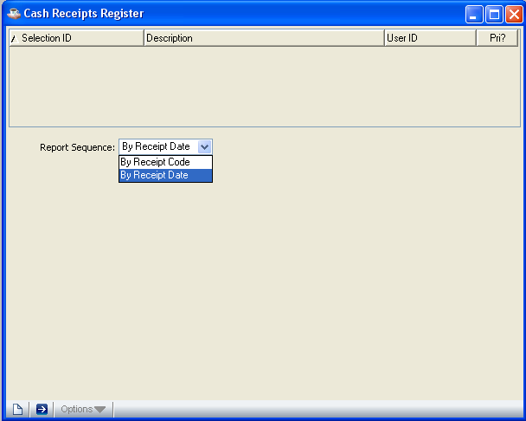

Cash Receipts Register

Function
The Cash Receipts Register prints a report of all cash receipts transactions entered through the Cash Receipts Entry task. If correct, all transactions are posted to the customer accounts, general ledger and optionally, the Bank Reconciliation system (in the General Ledger module

n To access the Cash Receipts Register...

Select Cash Receipts Register from the Accounts Receivable processing menu.

About the Fields

In the Sequence field...
• Select By Receipts Code to print the register by cash receipt code.

- Select By Receipts Date to print the register by receipt date.

The following prompt is issued:

• Click the Run Process button when the information is correct and proceed with the printing.
- Press the New buttonto begin a new Cash Receipts Register.

If you attempt to leave an unsaved Cash Receipts Register by clicking New button, the module will issue a confirmation box as follows:

- Click Yes to save the current record and proceed with printing of Cash Receipts Register by corresponding report sequence.

- Click No to return to the report sequence field in cash receipts register form without printing.
- Click Cancel or the Close Window button to return to the current cash receipts register screen.
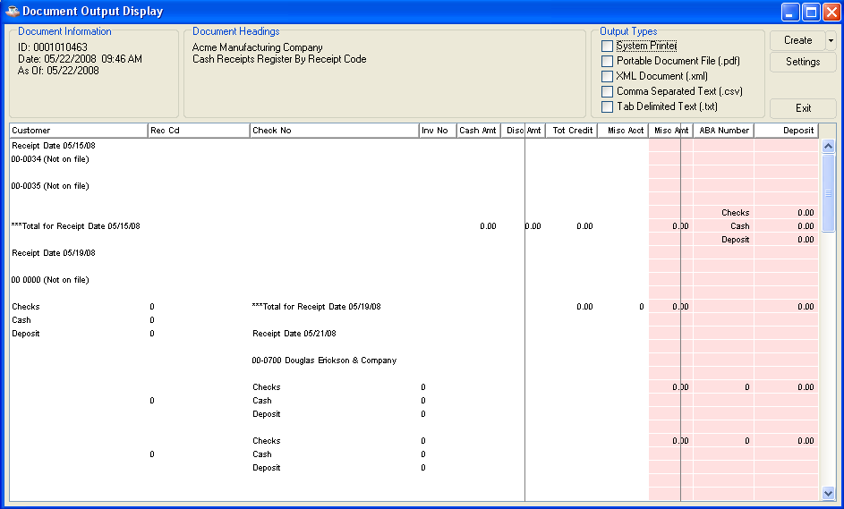

Note: Any data shaded with pink in the Document Output window is at risk of truncation when the document is printed or saved in pdf format. Click and drag to adjust column sizes until no pink shading remains. If the report is too large to adjust in this manner, save it in one of the disk file formats (xml, cxv, txt) in order to prevent data loss.

Choose your Output Type and click the Create button. After the file is created or printed, click the Close Window button to close the Document Output Display window.

Once the register is printed, the following prompt is issued:

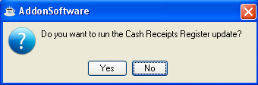
• Click Yes when the register printed correctly and to proceed with the update.

- Click No when the update should be postponed and to return to the Accounts Receivable menu without updating.

Updating
For each customer on the register, the amounts entered in the Cash Receipts Entry task are posted to their open invoices or on-account. The general ledger is posted as follows:

a) The cash account is determined by the cash receipts code.

b) The accounts receivable account is determined by the distribution code associated with the invoice when it was entered, not the current distribution code associated with the customer.

c) The terms discount account is determined by the cash receipts code associated with each cash receipt transaction.

d) In the case of cash posted on-account, the default distribution code associated with the customer determines the accounts receivable account.

e) Miscellaneous general ledger transactions are posted to the accounts entered through the Cash Receipts Entry GL Distribution display.

f) Transactions are written to the Cash Receipts History files.

When you have the Accounts Payable’s Bank Reconciliation and the Accounts Receivable module is interfaced to it, (Refer to Accounts Receivable Parameter Maintenance), a record of the cash received is posted to it. The month-to-date and/or next month cash receipt totals that appear at the bottom of the Cash Receipts Register are also updated at this time.

Aging Report

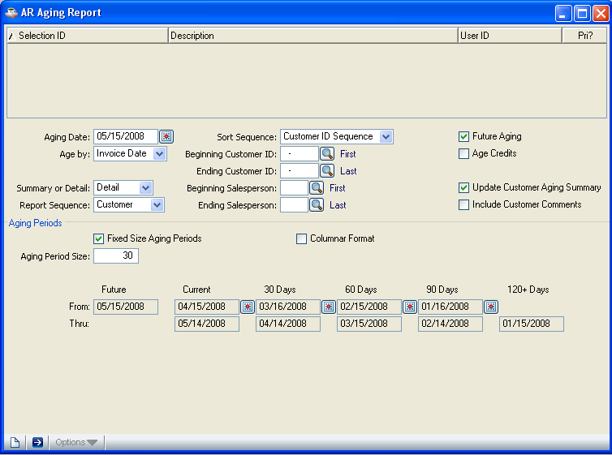

Aging Report

Function
The Aging Report prints an aged trial balance of customer accounts in either numeric or alphabetic sequence, with the option of displaying detail or summarized information for each customer.

n To access the Aging Report...

Select Aging Report from the Accounts Receivable processing menu.

About the Fields

In the Aging Date field...
• Press the icon to select the date upon which aging is based.

In the Age by field...
• Select Due Date to age all invoices based on their due date.

- Select Invoice Date to age all invoices based on their invoice date.

NOTE: When using the aging report to help determine whether or not a customer should be assessed finance charges, pay close attention to the date selected for aging.

In the Future Aging field...
• Check Future Aging box to include all invoices and payments regardless of their dates.

- Uncheck Future Aging box to exclude any accounts receivable transactions that occurred after the aging date for the report being run, such as a payment received after the end of the period.

NOTE: For an aging report that can be used to balance the accounts receivable general ledger account, select I (for invoice) in the Age On Due Date Or Invoice Date field and N in the Future Aging field.

In the Report Sequence field...
• Select Customer for a report sorted by customer number.

- Select Salesperson for a report sorted by salesperson code.

In the Sort Sequence field...
- Select Alternate Sequence to sort in alphabetical order.

- Select Customer ID Sequence to sort in numeric sequence by customer number.

In the Beginning With field...
• Enter the first customer number(depending on Report Sequence field) to begin the report.

- Press Enter to start with the first on file.

- Click the Find button to select from a list of all valid customers.

In the Ending With field...
• Enter the last customer number or salesperson code to end the report.

- Press Enter to end with the last on file.

- Click the Find button to select from a list of all valid customers.

NOTE: The Beginning and Ending fields represent lower and upper ranges that are printed, regardless of whether the report is printed in alphabetic or numeric sequence.

In the Update Customer Aging Summary field...
• Check Update Customer Aging Summary box to update customer information.

- Uncheck Update Customer Aging Summary box to print the report without updating customer information. Example: if the current month is June, but you want to print an aging as of February 28, uncheck this box so that the aging displayed under customer maintenance is not changed to reflect February amounts.

- Press Enter to leave blank and proceed to the next field.

In the Summary Or Detail field...
• Select Summary to print a single line for each customer.

- Select Detail to print all open invoices for each customer.

In the Include Customer Comments field...
• Check Include Customer Comments box to include comments on the report that are associated with the customer.

- Uncheck Include Customer Comments box to print the report without customer comments.

- Press Enter to leave blank and proceed to the next field.

In the Age Credits field...
- Check Age Credits box to include credit balances on the printed report.

- Uncheck Age Credits box to print the report without credit balances.

- Press Enter to leave blank and proceed to the next field.

In the Fixed Size Aging Periods field...
- Check Fixed Size Aging Periods box to use fixed size for all buckets The system will automatically calculate the periods using aging date and aging period size.

- Uncheck Fixed Size Aging Periods box to enter date for each bucket separately.

In the Aging Period Size field...
- Enter the number of days for each aging bucket. The number must be at least one (1) and can range up to 999.

In the Columnar Format field...

- Check Columnar Format box to show the printed report in columnar format.

- Uncheck Columnar Format box to show in non columnar format.
The system prompts:

• Click the Run Process button when the information is correct and proceed with the printing.

- Click the New button to enter another Aging Report details.

If you attempt to leave an unsaved Aging Report by clicking New button, the module will issue a confirmation box as follows:

- Click Yes to save the current record and proceed with printing the report

- Click No to return to the Aging Date field in Aging Report form without printing and saving.

- Click Cancel to return to the current Aging Report screen.

Printing
As the Aging Report prints, the aging summary figures are recalculated for each customer and written to the Customer Masterfile when the response to the Update Customer Aging question is Yes.

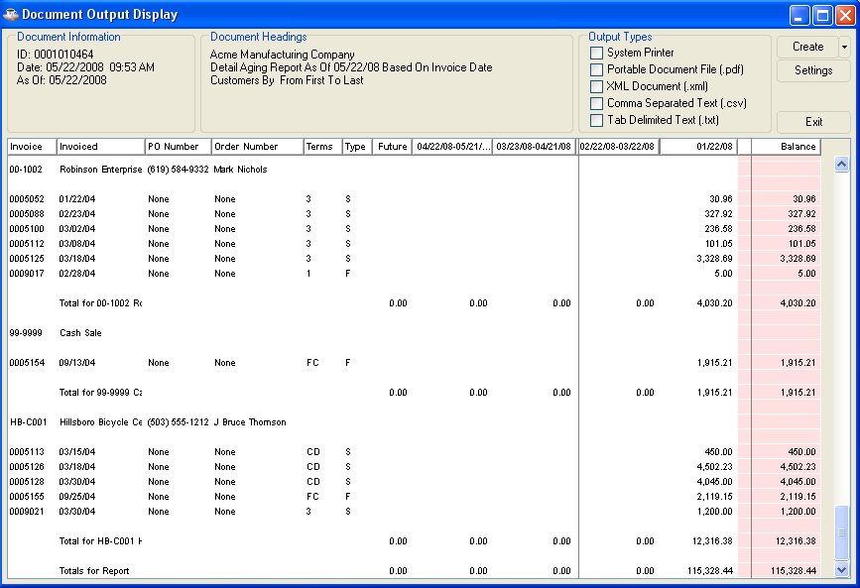

Aging Analysis Report

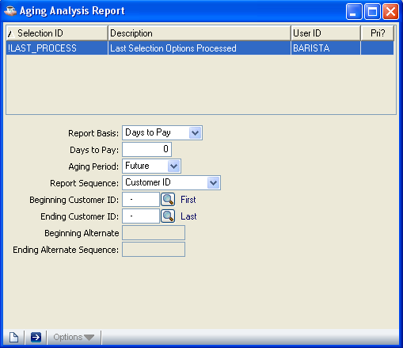

Aging Analysis Report

Function
The Customer Aging Analysis Report provides information on selected customers’ accounts receivable balance by aging period. Information is available by either average days to pay or balance by aging period. The report is available by customer number or alternate sequence sort.

n To access the Aging Analysis Report...

Select Aging Analysis Report from the Accounts Receivable processing menu.

About the Fields

In the Report Basis field...
• Select Days to pay to select customers based on the average number of days to pay.

- Select Aging Balances to select customers to print based on their current aging balance for the various aging categories (i.e. 30, 60, 90, etc.).

In the Days to pay field...
• Enter the number of days that a customer must have in “average days to pay” in order to be included on the report.

In the Aging Period field...

Enter the number of the aging period (Future/Current/30/60/90/120) for which a customer must have a balance due in order to be included on the report.

Example
When you select Days to pay in the Report Basis field and enter 45 for the Days field, only customers with average days to pay of 45 or greater are included on the report.

When you select Aging Balances in the Report Basis field and enter 90 for the Days field, only customers with a balance of 90 days or greater are included on the report.

In the Report Sequences field...
• Select Alternate Sequence to print the report sorted by customers in alternate sequence.

- Select Customer ID to print the report sorted in customer number sequence.

In the Beginning Customer field...
• Enter a number representing the first customer number to print(depending on Report Sequence field).

- Press Enter to begin with the first customer in the file.

- Click the Find button to select from a list of all valid customer numbers.

In the Ending Customer field...
• Enter a number representing the last customer number to include on the report.

- Press Enter to end with the last customer on file.

- Click the Find button to select from a list of all valid customer numbers.

NOTE: The Begin With and End With fields represent a lower and upper range of customer numbers to print regardless of whether the report is printed in alphabetic or numeric sequence.

In the Beginning Alt Seq field...
- Enter a beginning alternate sequence for a customer.

- Press Enter to begin with the first customer, alphabetically in the file.

In the Ending Alt Seq field...
- Enter an ending alternate sequence for a customer.

- Press Enter to end with the last customer, alphabetically on file.

The following prompt is issued:

• Click the Run Process button when the report options are set correctly and proceed with the printing.

- Click the New button to begin a new Aging Analysis Report .

If you attempt to leave an unsaved Aging Analysis Report by clicking New button, the module will issue a confirmation box as follows:

- Click Yes to save the current record and proceed with printing the report.

- Click No to return to the Aging Analysis Report without printing the report.

- Click Cancel or the Close Window button to return to the current Aging Analysis Report

Printing

As the report prints, “Aging Analysis Report” is displayed on the progress bar to indicate the progress of the printing.

Age Accounts Receivable Transactions
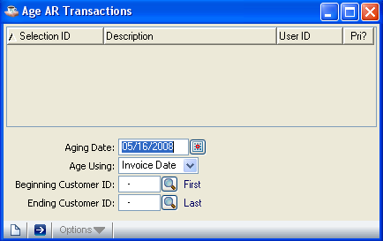
Age Accounts Receivable Transactions

Function
When the Accounts Receivable Aging Report is printed, the aging summary figures are recalculated for each customer and written to the Customer Masterfile. To recalculate the aging summary figures without printing an Aging Report, use the Age Accounts Receivable Transactions task. When desired, this task will also perform aging for a single customer or series of customers.

n To access the Age Accounts Receivable Transactions...

Select Age Transactions from the Accounts Receivable processing menu.

About the Fields

In the Aging Date field...
• Click the Calendar button to select the date upon which aging is based.

In the Age Using field...

• Select Age Using on Invoice date

- Select Age Using on Due Date

In the Beginning Customer field...
• Enter the customer number with which to start the report.

- Press Return to start with the first customer number on file.

- Click the Find button to select from a list of all valid customer numbers.

In the Ending Customer field...
• Enter the customer number with which to end the report.

- Press Return to end with the last customer number on file.

- Click the Find button to select from a list of all valid customer numbers.

- Click the New button to begin a new Age Transactions processes .

If you attempt to leave an unsaved Age Transactions by clicking New button, the module will issue a confirmation box as follows:

- Click Yes to save the current record and proceed with Age Transactions processes.

- Click No to return to the Age Transactions screen without Age Transactions processes.

- Click Cancel or the Close Window button to return to the current Age Transactions screen.

Accounts Receivable Reports
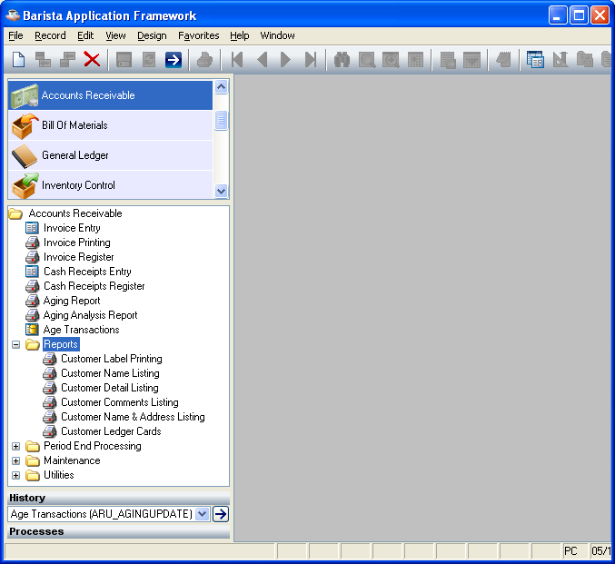
Accounts Receivable Reports Menu

Function
The reports and listings available to the Accounts Receivable module have all been gathered together in this task to make it easier for you to access them. Use this task when you want to print labels or ledger cards, etc., or to print customer information of several types.

n To access the Accounts Receivable Reports...

Select the Reports button after accessing Accounts Receivable.

Customer Label Printing
The Customer Label Printing task prints mailing labels for each customer based on the options entered. The label format is adjustable and is specified in the Accounts Receivable parameters.

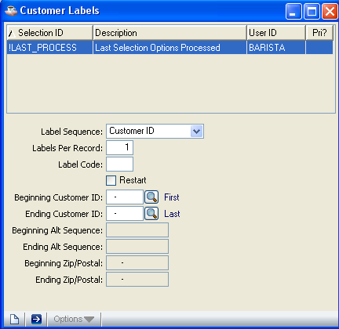

In the Label Seq field...
• Select Customer ID to print labels in customer number sequence.

- Select Alternate sequence to print labels in customer alternate sequence.

- Select Zip/Postal Code to print labels in customer zip code sequence.

- Click the Close Window button to return to the Accounts Receivable Reports Menu.

In the Labels Per Record field...
• Enter the number of labels you want to print for each customer record.

Example
When you select 6 labels per record and you have 100 customers, you will receive 6 labels for each customer for a total of 600 labels.

In the Label Code field...
• Enter a label code to print labels for customers with that code. The label code is set up for each customer in the Customer Maintenance task.

- Press Enter to print labels for all customers in the selected sequence.

In the Restart field...
• Check Restart box to restart label printing by selecting a range of customers

- Uncheck Restart box to print all customer labels from the first through the last.

- Press Enter to leave blank and proceed to the next field.

In the Enter Beginning Customer ID field...
• Enter the starting customer number (depending on Label Type). Labels will start printing from this information.
- Click the Find button to select from a list of all valid customer numbers.

- Press Enter to start with the first possible record.

In the Enter Ending Info field...
• Enter the customer number (depending on Label Type). Labels will print through this information.
- Click the Find button to select from a list of all valid customer numbers.

- Press Enter to end with the last possible record.

In the Enter Beginning Alt Seq field...
- Enter beginning alpha selection(depending on Label Type)

- Press Enter for the first record.

In the Enter Ending Alt Seq field...
- Enter ending alternate sequence(depending on Label Type).

- Press Enter for the last record.

In the Enter Beginning ZIP Code field...
- Enter starting ZIP code(depending on Label Type).

- Press Enter for the first record.

In the Enter Ending ZIP Code field...
- Enter ending ZIP Code number(depending on Label Type).

- Press Enter for the last record.

The following prompt is issued:
• Click the Run Process button when all information is correct.

- Click the New button to begin new Customer Label Printing Report:

If you attempt to leave an unsaved Customer Label by clicking New button, the module will issue a confirmation box as follows:

- Click Yes to save the current record and proceed with another prompt.
.
- Click No to return to the Label Sequence field in Customer Label Printing form
without saving the record.
- Click Cancel or the Close Window button to return to current Customer Label Printing form.

When you Click the Run Process button and press Yes to above prompt, another prompt is shown:

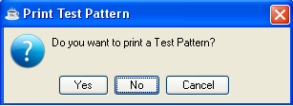

• Select yes to print a test pattern on the printer to assist in aligning the labels. You may print a test pattern as many times as is required to align the labels.

- Select No to start printing the labels without a test pattern.

Printing
As the report prints, “Customer Label Printing” is displayed on the progress bar to indicate the progress of the printing.

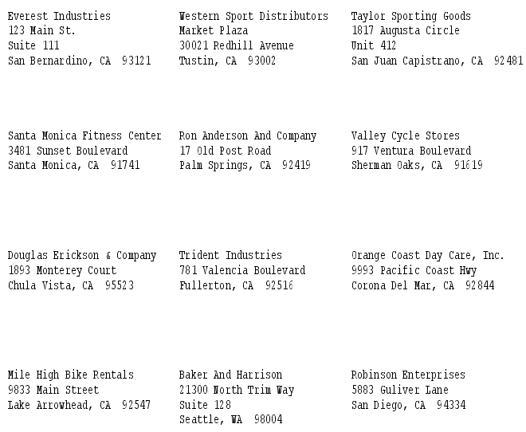

Customer Name Listing
The Customer Name Listing task prints account numbers and names for customers by selected salesperson, territory, terms code, or customer type.
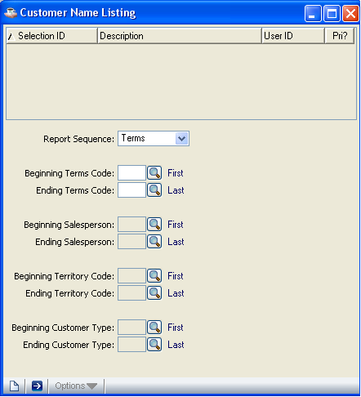

In the Report Sequence field...
• Select Terms to print customer names by terms code.

- Select Salesperson to print names by salesperson code.

- Select Territory to print names by territory code.

- Select Type to print by customer type.
- Click the Close Window button to return to the Accounts Receivable Reports Menu.

In the Beginning Terms Code field...
• Enter the starting terms code (depending on Report Sequence). The report will start printing from this code.

- Press Enter to start with the first possible code.

- Click the Find button to select from a list of codes.

In the Ending Terms Code field...
• Enter the last terms code (depending on Report Sequence). The report will print through this code.

- Press Enter to end with the last possible code.

- Click the Find button to select from a list of codes.

In the Beginning Salesperson Code field...
- Enter beginning salesperson code (depending on Report Sequence).

- Press Enter to begin with the first code on file.
- Click the Find button to select from a list of codes.

In the Ending Salesperson Code field...
- Enter ending salesperson code(depending on Report Sequence).

- Press Enter to end with the last possible salesperson code.
- Click the Find button to select from a list of codes.

In the Beginning Territory Code field...
- Enter beginning territory code(depending on Report Sequence).

- Press Enter to begin with the first territory code on file.
- Click the Find button to select from a list of codes.

In the Ending Territory Code field...
- Enter ending territory code(depending on Report Sequence).

- Press Enter to end with the first territory code on file.

- Click the Find button to select from a list of codes.

In the Beginning Customer Type Code field...
- Enter the beginning customer type code(depending on Report Sequence).

- Press Enter for the first possible customer type code.
- Click the Find button to select from a list of codes.

In the Ending Customer Type Code field...
- Enter the ending customer type code(depending on Report Sequence).

- Press Enter for the last possible customer type code.
- Click the Find button to select from a list of codes.

The following prompt is issued:

• Click the Run Process button when all information is correct and proceed with printing.

- Click the New button to begin new Customer Name Listing Report:

If you attempt to leave an unsaved Customer Name Listing by clicking New button, the module will issue a confirmation box as follows:

- Click Yes to save the current record and proceed with Customer Name Listing printing.
.
- Click No to return to the Report Sequence field in Customer Name Listing form
without saving the record.
- Click Cancel or the Close Window button to return to current Customer Name Listing form.

Printing
As the report prints, “Customer Name Listing” is displayed on the progress bar to indicate the progress of the printing.

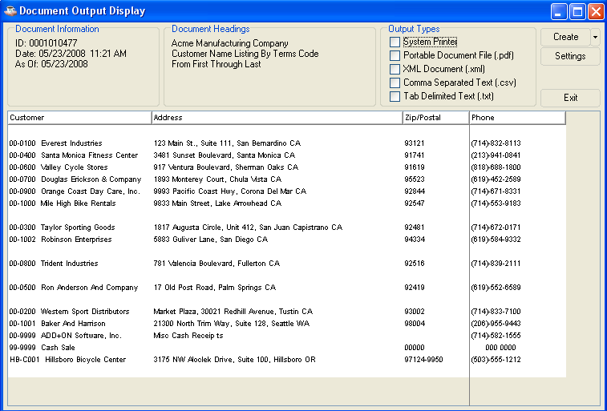

Customer Detail Listing
The Customer Detail Listing task prints a detail listing of customer information for all customers. This task is used primarily to verify the information entered in the Customer Masterfile during the installation process.

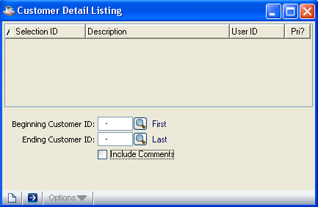

In the Beginning Customer field...
• Enter the beginning customer number.

- Press Enter to select the first customer number on record.

- Click the Find button to select from a list of all valid customer numbers.

In the Ending Customer field...
• Enter the ending customer number.

- Press Enter to select the last customer number on record.

- Click the Find button to select from a list of all valid customer numbers.

In the Include Comments field...
• Check Include Comments box to include comments on the listing.

- Uncheck Include Comments box to print the listing without comments.

The following prompt is issued:

• Click the Run Process button when all information is correct and proceed with printing.

- Click the New button to begin new Customer Detail Listing Report:

If you attempt to leave an unsaved Customer Detail Listing by clicking New button, the module will issue a confirmation box as follows:

- Click Yes to save the current record and proceed with Customer Detail Listing printing.
.
- Click No to return to the Beginning Customer ID field in Customer Detail Listing form
without saving the record.
- Click Cancel or the Close Window button to return to current Customer Detail Listing form.

Printing

As the report prints, “Customer Detail Listing” is displayed on the progress bar to indicate the progress of the printing.

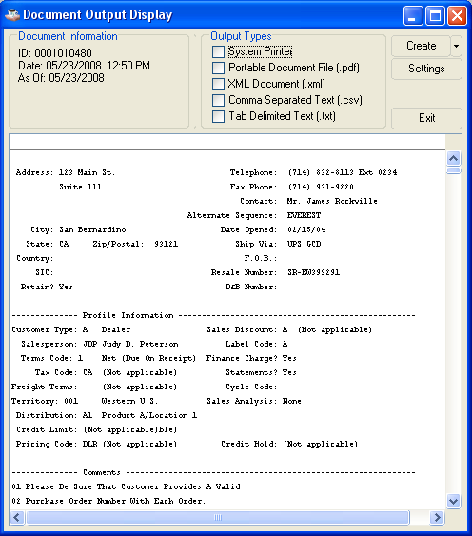

Customer Comments Listing
The Customer Comments Listing task prints customer comments as set up in the Customer Maintenance task, selected by salesperson or territory.
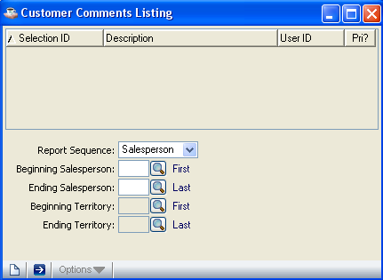

In the Report Sequence field...
• Select Salesperson to print customer comments by salesperson code.

- Select Territory to print customer comments by territory code.

- Click the Close Window button to return to the Accounts Receivable Reports Menu.

In the Beginning Salesperson Code field...
• Select the beginning salesperson code (depending on Report Sequence). The report will start printing from this code.

- Press Return to begin with the first possible code.

- Click the Find button to select from a list of all valid codes.

In the Ending Salesperson Code field...
• Select the last salesperson code (depending on Report Sequence).

- Press Return to end with the last possible code.

- Click the Find button to select from a list of all valid codes.

In the Beginning Territory Code field...
- Enter the first territory code on file(depending on Report Sequence).

- Press Return to begin with the first possible code.

- Click the Find button to select from a list of all valid codes.

In the Ending Territory Code field...
- Enter the last territory code on file (depending on Report Sequence).

- Press Return to end with the last possible code.

- Click the Find button to select from a list of all valid codes.

The following prompt is issued:

• Click the Run Process button when all information is correct and proceed with printing.

- Click the New button to begin new Customer Comments Listing Report:

If you attempt to leave an unsaved Customer Comments Listing by clicking New button, the module will issue a confirmation box as follows:

- Click Yes to save the current record and proceed with Customer Comments Listing printing.
.
- Click No to return to the Report Sequence field in Customer Comments Listing form
without saving the record.
- Click Cancel or the Close Window button to return to current Customer Comments Listing form.

Printing
As the report print, “Customer Comments Listing” is displayed on the progress bar to indicate the progress of the printing.

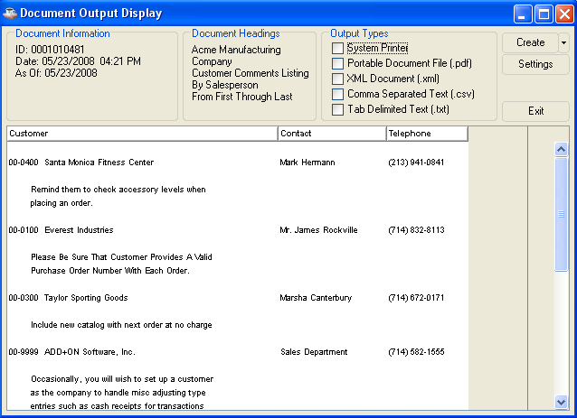

Customer Name and Address Listing
The Customer Name and Address Listing task prints an alphabetic or numeric listing of all customer names, addresses and telephone numbers.

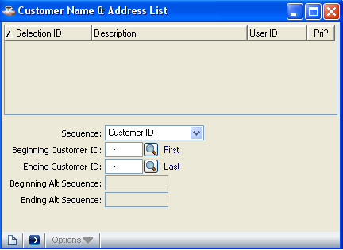

In the Customer/Alt Sequence field...
• Select Customer ID to print the report in customer number sequence.

- Select Alternate Sequence to print the report by alternate sequence.

In the Beginning Customer ID field...
• Enter the customer number with which to start the report(depending on Report Sequence).

- Press Return to start with the first customer number selection on file.

- Click the Find button to select from a list of all valid customers.

In the Ending Customer ID field...
• Enter the customer number with which to end the report(depending on Report Sequence).

- Press Return to end with the last customer number/alpha selection on file.

- Click the Find button to select from a list of all valid customers.

In the Beginning Alt Sequence Code field...
- Enter beginning sequence code(depending on Report Sequence).

- Press Return to begin with the first code on file.

- Click the Find button to select from a list of valid codes.

In the Ending Alt Sequence Code field...
- Enter the ending sequence code.(depending on Report Sequence).

- Press Return to end with the last code on file.
-or-
- Click the Find button to select from a list of valid codes.

The following prompt is issued:

- Click the Run Process button when all information is correct and proceed with printing.

- Click the New button to begin new Customer Name & Address List Report:

If you attempt to leave an unsaved Customer Name & Address List by clicking New button, the module will issue a confirmation box as follows:

- Click Yes to save the current record and proceed with Customer Name & Address List printing.
.
- Click No to return to the Sequence field in Customer Name & Address List form
without saving the record.
- Click Cancel or the Close Window button to return to current Customer Name & Address List form.

Printing
As the report print, “Customer name & address Listing” is displayed on the progress bar to indicate the progress of the printing.

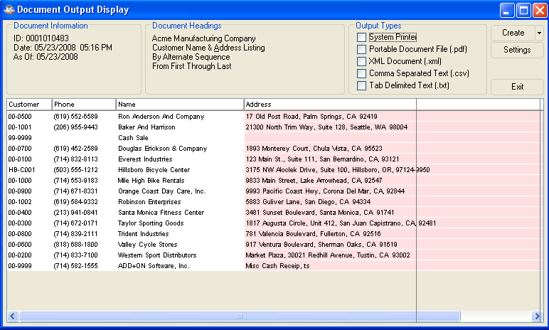

Customer Ledger Card Listing
The Customer Ledger Card Listing task lists all outstanding invoices, up to a selected date, for a range of customers. The information shown includes invoice number, date, date due, invoice amount, amount applied and invoice balance

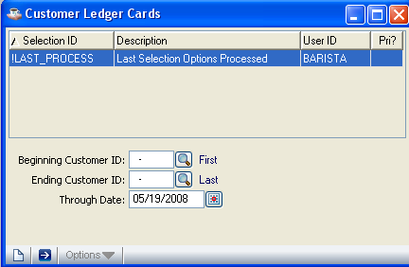

In the Beginning Customer ID field...
• Enter the number of the first customer for which a ledger card is desired.

- Press Return to begin with the first customer on file.

- Click the Find button to select from a list of all valid customers.

- Click the Close Window button to return to the Accounts Receivable Report Menu.

In the Ending Customer ID field...
• Enter the number of the last customer for which a ledger card is desired.

- Press Return to end with the last customer on file.

- Click the Find button to select from a list of all valid customers.

In the Through Date field...
• Click the Calendar button to enter the date through which transactions should be included.

Press Return to use the terminal date.

The following prompt is issued:

- Click the Run Process button when all information is correct and proceed with printing.

- Click the New button to begin new Customer Ledger Cards Report:

If you attempt to leave an unsaved Customer Ledger Cards by clicking New button, the module will issue a confirmation box as follows:

- Click Yes to save the current record and proceed with Customer Ledger Cards Reports printing.
.
- Click No to return to the Beginning Customer ID field in Customer Ledger Cards form without saving the record.
- Click Cancel or the Close Window button to return to current Customer Ledger Cards form.

Printing
As the report print, “Customer Ledger Cards” is displayed on the progress bar to indicate the progress of the printing.

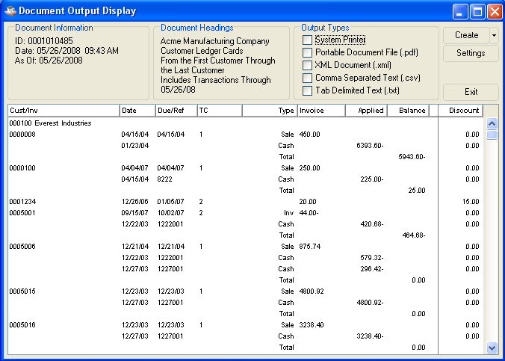

Period-End Processing
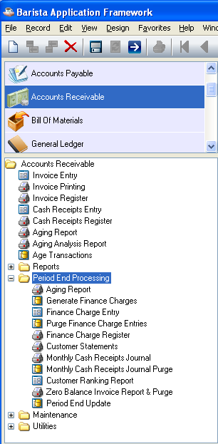
AR Period-End Processing Menu

Function
The Period-End Processing menu provides access to the tasks that are part of the accounts receivable period-end process. Other than the Period-End Update task itself, any of these selections may be run on demand at any time.

Shown above is the menu as it exists for the standard software. Your module may show a different list of tasks, depending on how it was installed or the custom changes that were made.

n To access the Period-End Processing menu...

Select Period End button after accessing Accounts Receivable.

About the Period-End Processing Tasks
To access any task on this menu, enter the number assigned to the task in the Enter An Option field.

Aging Report
The Period-End Processing Aging Report is exactly the same as that which is documented as part of the Accounts Receivable main menu in the previous Aging Report section. It appears on both the main menu and the period end menu solely for the convenience of the operator.

Generate Finance Charges
The Finance Charge Creation task automatically creates finance charge invoices for customers based on days overdue, invoice amount, finance charge rate and minimum finance charge amount. This is the first step of applying finance charges to customer accounts, followed by the printing of the Finance Charge Register and the update. Finance charges for individual customers may also be entered or modified using the Finance Charge Entry task.

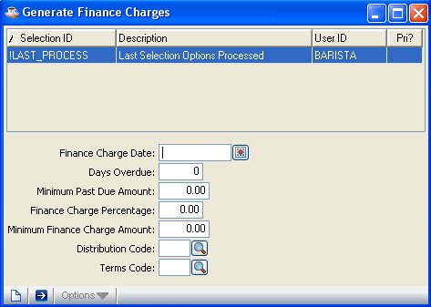

In the Finance Charge Date field...
• Click the Calendar button to enter a valid date.

- Click the Close Window button to return to the Period-End Processing Menu.

This date is the accounting date of the finance charge. The due date and days overdue are calculated using this date as a base and the assigned terms code.

In the Days Overdue field...
• Enter the number of days that an invoice must be overdue in order to have finance charges applied.

The days overdue are calculated from the finance charge date entered in the Date field. Open invoices dated on or before this date are considered for finance charges.

Example
For instance, when the finance charge date is 12/30/04 and the days overdue is 60, only open invoices with due dates on or before 10/31/04 are considered for finance charge calculation.

In the Minimum Past Due Amount field...
• Enter the minimum dollar amount for an invoice to be considered for finance charge calculation.

Example
Enter 10.00 to consider invoices which are $10.00 or greater for finance charges.

In the Finance Charge % field...
• Enter the percentage rate to be used in finance charge calculation.

This is the percentage rate that applies to this particular application of the finance charge.

Example
Enter 1.25 to calculate finance charges of 1.25% (.0125). When an overdue invoice is $150 and the finance charge percent is 1.25, the amount of the finance charge is $1.88.

In the Minimum Finance Charge Amount field...
• Enter the smallest finance charge amount that is to be applied to an invoice.

When a calculated finance charge is smaller than this amount, it is replaced with the minimum finance charge amount. In other words, whenever a finance charge is applied, it is this amount or greater.

Example
When you enter 1.00, finance charges less than $1.00 are not applied to eligible invoices.

In the Distribution Code field...
• Enter a valid general ledger distribution code.

Click the Find button to select from a list of all valid distribution codes.

This code will determine the general ledger postings for the accounts receivable and finance charge revenue accounts, when selected as part of the update process.

In the Terms Code field...
• Enter a valid terms code.
- Click the Find button to select from a list of all valid terms codes.

This code will determine the due date of the finance charge based on the finance charge date.

The following prompt is issued:
- Click the Run Process button when all information is correct.

- Click the New button to begin new Generate Finance Charges:

If you attempt to leave an unsaved Generate Finance Charges by clicking New button, the module will issue a confirmation box as follows:

- Click Yes to save the current record and proceed with another prompt.
.
- Click No to return to the Finance Charge Date field in Generate Finance Charges form without saving the record.
- Click Cancel or the Close Window button to return to current Generate Finance Charges form.

When you Click the Run Process button and press Yes to above prompt, another prompt is shown:

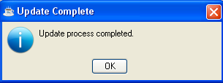

Processing
The task will search through all open accounts receivable invoices. The invoice number being examined is displayed on the screen. When the invoice is overdue, the balance is checked for minimum size. If the balance is large enough, the finance charge amount is calculated. When the finance charge amount is large enough, a finance charge record is created.

NOTE: Finance charges generated through this process may be modified or deleted using the Finance Charge Entry task prior to updating the Finance Charge Register.

Finance Charge Entry
The Finance Charge Entry task allows you to enter finance charges for individual customers or modify finance charges automatically created by the Finance Charge Creation task. This task may be run after reviewing the Finance Charge Register in order to adjust the finance charges for specific customers.

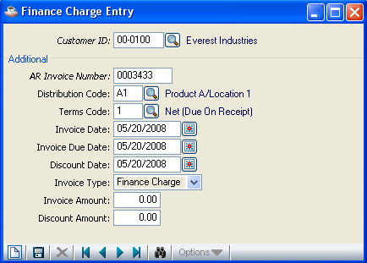

NOTE: This task is the same as the Conversion Invoice Entry task, and uses the same data entry file. Therefore, care should be taken to separate the Finance Charge Entry process from the Conversion Invoice Entry process.

In the Customer Number field...
• Enter a valid customer number. The associated customer name also appears automatically.

- Click the Find button to select from a list of all valid customer numbers.

- Click the Close Window button to return to the menu.

In the AR Invoice Number field...
• Enter a seven-digit invoice number that is used to identify the finance charge transaction.

When the invoice has already been updated to the Accounts Receivable Open Invoice file, you will not be able to enter the transaction. To adjust invoices, refer to the Cash Receipts Entry or Simple Invoice Entry tasks.

In the Distribution Code field...
• Enter a valid distribution code. The description of the code is displayed.

- Press Return to accept the code associated with the customer. (Refer to the Customer Maintenance task in the Accounts Receivable Maintenance section.)

- Click the Find button to select from a list of all valid distribution codes.

The distribution code determines the general ledger account numbers for finance charge revenue, accounts receivable and discounts when the finance charge is updated.

NOTE: You may want to define a distribution code called FC just for finance charges. Refer to the Distribution Code Maintenance task for more information.

In the Terms Code field...
• Enter a valid terms code. The description of the code is displayed.

- Press Return to use the default terms code associated with the customer. (Refer to the Customer Maintenance task in the Accounts Receivable Maintenance section.)

- Click the Find button to select from a list of all valid terms.

The terms code will determine the due date and discount due date for the finance charge, using the invoice date as a reference point. Normally, finance charges are set up with terms code of net or due on receipt.

In the Invoice Date field...
• Click the Calendar button to enter the date that the finance charge is to be posted to general ledger.

This date is used as the reference point by the terms code to determine the due date and discount due date of the finance charge. These dates are displayed and may be overridden if desired.

In the Invoice Due Date field...
• Click the Calendar button to enter the date that the finance charge is due.

- Press Return to accept the default.

In the Discount Due field...
• Click the Calendar button to enter the date through which the customer may take the discount.

- Press Return to accept the default.

Discounts are not generally offered on finance charges.

In the Invoice Type field...
• Select Finance Charge when the transaction is a finance charge.

In the Invoice Amount field...
• Enter the total amount of the finance charge.

When adjusting a finance charge that was generated automatically by the Finance Charge Creation task, this becomes the new amount.

In the Discount Amount field...
• Enter the amount of discount available on this finance charge, if applicable.

NOTE: Discounts are recorded as memo amounts only at this point. They are not posted to general ledger until after they are actually taken. This is determined during cash receipts processing.

The following prompt is issued:

- When you have finished making finance charge entries, Click the Save button to save details.

- Click the New button to begin new Finance Charge Entry:

If you attempt to leave an unsaved Finance Charge Entry by clicking New button, the module will issue a confirmation box as follows:

- Click Yes to save the current record. The form is cleared in preparation for a new entry.
.
- Click No to return to the Finance Charge Date field in Finance Charge Entry form without saving the record.
- Click Cancel or the Close Window button to return to current Finance Charge Entry form.
- Click the Delete button to erase the current finance charge entry from the data entry file.

Purge Finance Charge Entries
The Purge Finance Charge Entries task remove all generated and entered finance charges.
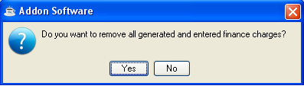

- Click Yes then following prompt is issued:

- Click No to return to the purge finance charge entries menu.

Finance Charge Register
The Finance Charge Register task prints a report of all calculated finance charges prior to making postings to the customers’ accounts. Included are all finance charges automatically created by the Finance Charge Creation task and manually entered through the Finance Charge Entry task. Finance charges may be optionally posted to the general ledger.

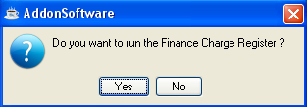

NOTE: Because the Finance Charge Register is printed from the same file as that used by the Conversion Invoice Register, each of these processes should be run separately to avoid confusion between them.

• Click Yes to print the register.

- Click No to return to the menu without printing.

NOTE: Any finance charge that is automatically generated through the Finance Charge Creation task may be modified or deleted using the Finance Charge Entry task prior to updating the Finance Charge Register.

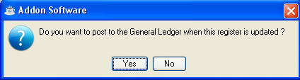

• Click Yes to update the general ledger. A general ledger summary page will print for your inspection. You must also update the Finance charge Register in order for the general ledger postings to take place.
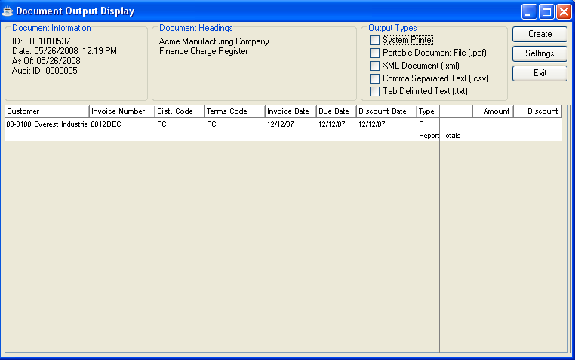

- Click No if you do not want to post transactions to the general ledger but still have them added to the customer’s open invoice files when the Finance Charge Register is updated.

Printing
The customer numbers are displayed on the screen as the register is printed.
After printing and inspecting the register, you may choose whether or not to update the selection when the system issues this prompt:
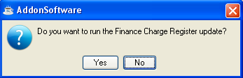

• Click Yes to post the result of the finance charge calculation to the customer’s AR Open Item files and create general ledger postings.

- Click No to return to the AR Period-End Processing Menu without updating. Transactions will remain unposted in the AR open invoice file until the Finance Charge Register is updated.

Updating
The finance charges are posted to the customers’ accounts. When the option is selected to post to general ledger and the Finance Charge Register is also updated, the amount of the finance charge is debited to the accounts receivable account and credited to the revenue account. The accounts set up for the finance charge distribution code in the Accounts Receivable Distribution Code Maintenance task will be used.

Where individual finance charges are entered using the Finance Charge Entry task, the distribution code established for each of those entries is used.

Customer Statements
The Customer Statements task selects and prints customer statements. Statements may be printed only for those customers who have the Statements field set to Y in the Customer Masterfile. Zero and credit balance statements are not printed, nor are the paid invoices from prior months. An additional selection criterion is provided and the statements may be restarted in the event of a paper jam or printer malfunction.
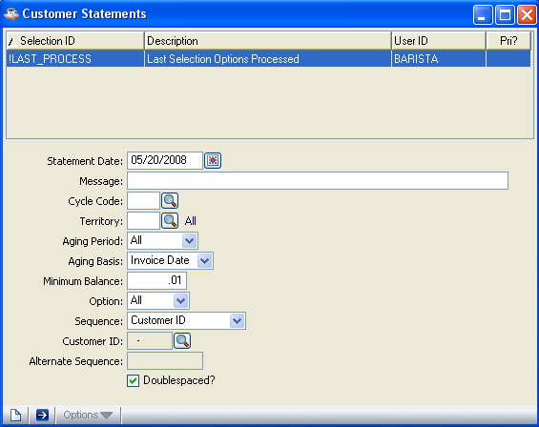

In the Statement Date field...
• Click the Calendar button to enter the date that will serve as the cutoff date for all transactions that are to appear on the statement. This date also serves as the reference date for calculating the Aging Summary printed at the bottom of the statement.

- Press Return to default to the terminal date.

- Click the Close Window button to return to the menu.

In the Message field...
• Enter up to 60 characters of a general message to print on each statement.

Messages are usually used for holiday greetings or for changes in company billing policies, special notes, etc.

In the Cycle Code field...
• Enter the cycle code for this statement run.

- Press Enter to select all codes.

- Click the Find button to select from a list of all valid codes.

In the Territory field...
• Enter a valid territory code.

- Press Enter to select all territories.
-
- Click the Find button to select from a list of all valid codes.

In the Aging Period field...
• Select All to print statements for all customers who have an accounts receivable balance.

- Select 30 days to include customers who have accounts receivable balances of 30 days and older.

- Select 60 days to only include customers who have a balance of 60 days and older.

- Select 90 days to only include customers who have a balance of 90 days and older.

- Select 120 days to only include customers who have a balance of 120 days and older.

In the Aging Basis field...
• Select Due Date to calculate the invoice aging by due date.

- Select Invoice Date to calculate the invoice aging by invoice date.

In the Minimum Balance field...
• Enter the aging minimum balance for which statements are printed.
Statements will not be printed for aging balances less than this amount.

In the Option field...
• Press Enter to print statements for all customers who meet the selected criteria.

- Select Restart to restart with a selected customer and print through the end.

- Select Singlet to print a statement for one customer only.

In the Sequence field...
• Select alternate sequence to print the statements in alternate sequence order.

- Select Customer ID to print the statements in numerical order.

This field defaults to numeric order when printing only one customer statement.

In the Customer ID field...
This field is not available if All was selected in the Option field.
When statements are to be printed in numeric order:
• Enter a valid customer number.

- Click the Find button to select from a list of all valid numbers.

In the Alternate Sequence field...
When statements are to be printed in sequence:
• Enter the letter of the alphabet from where the printing is to begin.

This field is used to tell the system where to restart a print job that is interrupted for any reason.

- Click the Run Process button when all information is correct and proceed with printing.

- Click the New button to begin new Customer Statements:

If you attempt to leave an unsaved Customer Statement by clicking New button, the module will issue a confirmation box as follows:

- Click Yes to save the current record and proceed with Customer Statement printing.
.
- Click No to return to the Statement Date field in Customer Statement form without saving the record.
- Click Cancel or the Close Window button to return to current Customer Statement form.

----------------------------------------not display in barista-----------------------------------------

When you enter Y to the previous prompt, the system issues another:

Do You Want To Print A Test Pattern?

• Enter Y to print a test pattern on the printer to assist in aligning the forms. You can run the test as many times as needed.
-or-
Enter N to start printing the statements.
-or-
Press F4 to return to the menu.

----------------------------------------not display in barista-----------------------------------------

Printing
As the report print, “Customer Statement” is displayed on the progress bar to indicate the progress of the printing.

Monthly Cash Receipts Journal
The Monthly Cash Receipts Journal task prints a detailed report of selected cash receipts in customer number sequence for a selected time period. A general ledger recap of all transactions is available.

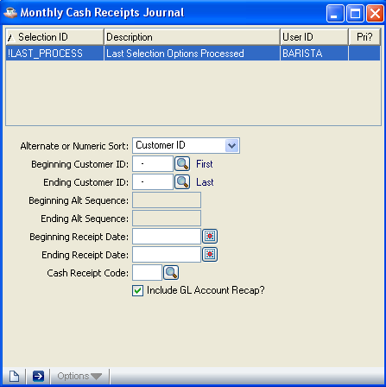

In the Alt Or Numeric Sort Sequence field...
• Select alternate sequence to print the journal by alternate sequence.

- Select Customer ID to print the journal by customer number.

In the Beginning Customer ID field...
• Enter a valid customer number(Depending on Alternate or Numeric Sort).

- Press Return to select the first customer number on file.

- Click the Find button to select from a list of all valid customers numbers.

In the Ending Customer field...
• Enter a valid customer number (Depending on Alternate or Numeric Sort field).

- Press Return to select the last customer number on file.

- Click the Find button to select from a list of all valid customer numbers.

In the Beginning Alt Sequence field...
- Enter a number representing an alternate sequence of customer numbers(Depending on Alternate or Numeric Sort field).

- Press Return to begin with the first customer number on file.

In the Ending Alt Sequence field...
• Enter a number representing the end of an alternate sequence of customer numbers.
(Depending on Alternate or Numeric Sort field).
- Press Return to end with the last customer number on file.

In the Beginning Receipt Date field...
• Click the Calendar button to enter the receipt date from which you want to start printing the Cash Receipts Journal.

- Press Return to start with the first possible date.

In the Ending Receipt Date field...
• Click the Calendar button to enter the receipt date through which you will include invoices on the Cash Receipts Journal.

- Press Return to end with the last possible date.

In the Cash Receipt Code field...
• Enter a valid cash receipt code.

- Press Return to select all codes.

- Click the Find button to select from a list of all valid codes.

In the Include GL Account Recap field...

- Click on the check box to indicate Yes to include GL Account Recap on the report.

- Press Return to leave blank and proceed to the next field.

The following prompt is issued:

- Click the Run Process button when all information is correct and proceed with Monthly Cash Receipts Journal report printing.
- Click the New button to begin new Monthly Cash Receipts Journal:

If you attempt to leave an unsaved Monthly Cash Receipts Journal by clicking New button, the module will issue a confirmation box as follows:

- Click Yes to save the current record and proceed with Monthly Cash Receipts Journal report printing.
.
- Click No to return to the Alternate or Numeric Sort field in Monthly Cash Receipts Journal form without saving the record.
- Click Cancel or the Close Window button to return to current Monthly Cash Receipts Journal form.

Printing
As the journal is printed, its progress is displayed on the progress bar.

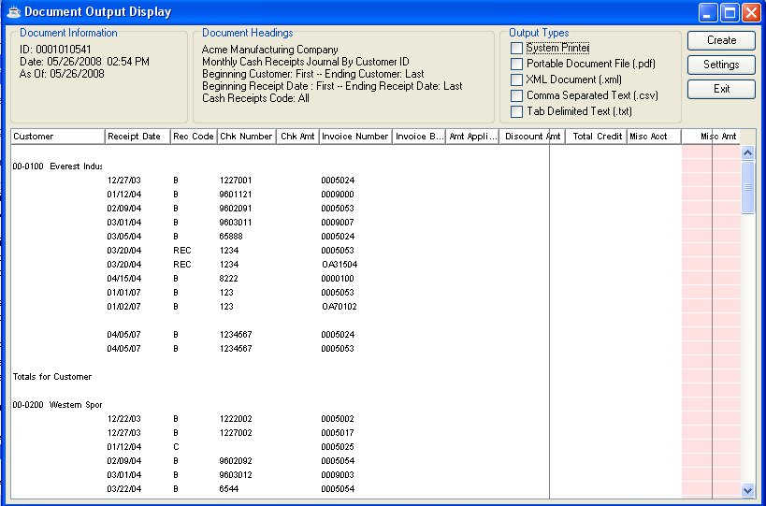

Monthly Cash Receipts Journal Purge
The Monthly Cash Receipts Journal Purge task clears the Monthly Cash Receipts Journal as of a specified date. The journal file may contain a record of cash receipts for several months. Periodically, it should be reviewed and cleared if the size of the file becomes excessive.

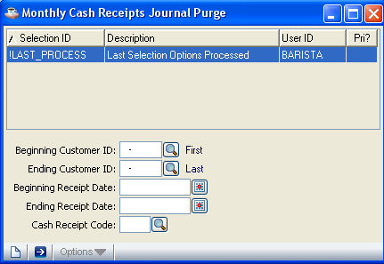

NOTE: If required, make certain you have printed a copy of the Monthly Cash Receipts Journal before running the purge.

In the Beginning Customer field...
• Enter a valid customer number.

- Press Return to select the first number on record.

- Click the Find button to select from a list of all valid customer numbers.

In the Ending Customer field...
• Enter a valid customer number.

- Press Return to select the last customer number on record.

- Click the Find button to select from a list of all valid customer numbers.

In the Beginning Receipt Date field...
• Click the Calendar button to enter the starting date of the receipts to be purged.

- Press Return to select the first date on record.

In the Ending Receipt Date field...
• Click the Calendar button to enter the last date of the receipts to be purged.

- Press Return to select the last date on record.

In the Cash Receipt Code field...
- Enter a valid cash receipt code.

- Press Enter to select all codes.

- Click the Find button to select from a list of all valid codes.

The following prompt is issued:

• Click the Run Process button when all information is correct and proceed with remove all receipts through the purge date.

- Click the New button to begin new Monthly Cash Receipts Journal Purge:

If you attempt to leave an unsaved Monthly Cash Receipts Journal Purge by clicking New button, the module will issue a confirmation box as follows:

- Click Yes to proceed with remove all receipts through the purge date.

- Click No to return to the Beginning Customer ID field in Monthly Cash Receipts Journal Purge form .
- Click Cancel or the Close Window button to return to current Monthly Cash Receipts Journal Purge form.

Processing
As the receipts are removed from the journal, progress is displayed on the progress bar.

Customer Ranking Report
The Customer Ranking Report task prints a report showing sales to and profits from all customers, ranked by month-to-date or year-to-date sales, profit or profit as a percent of sales. A customer number sort is also available (not ranked) and ranking by territory code, salesperson code or customer type may be selected for any report.

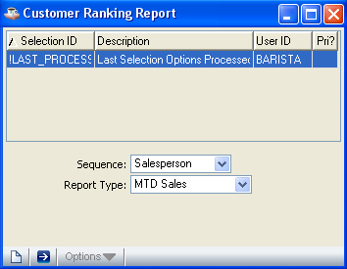

NOTE: The sales and profit information shown on each Customer Ranking Report is derived from the aging and sales data. It includes Simple Invoices (which include no costs) and type “O” line items as well as standard sales data.

In the Sequence field...
• Select Sequence field from the list below that represents how the customer information is ranked.

- Salesperson
- Territory
- CustomerType
- Customer ID

In the Report Type field...
• Select Report Type from the list below that represents the type of ranking for the report.

- MTD Sales (Month-to-date gross dollar sales)
- MTD Gross Profit (Month-to-date gross profit)
- MTD Gross Profit % (Month-to-date profit as a percentage of gross sales)
- YTD Sales (Year-to-date gross dollar sales)
- YTD Gross Profit (Year-to-date gross profit)
- YTD Gross Profit % (Year-to-date profit as a percentage of gross sales)
- Customer ID (Customer number)

- Click the Close Window button to return to the Period-End Processing Menu.

The following prompt is issued:

• Click the Run Process button when all information is correct and proceed with Customer Ranking Report.

- Click the New button to begin new Customer Ranking Report:

If you attempt to leave an unsaved Customer Ranking Report by clicking New button, the module will issue a confirmation box as follows:

- Click Yes to proceed with Customer Ranking Report.

- Click No to return to the Sequence field in Customer Ranking Report form.
- Click Cancel or the Close Window button to return current Customer Ranking Report form.

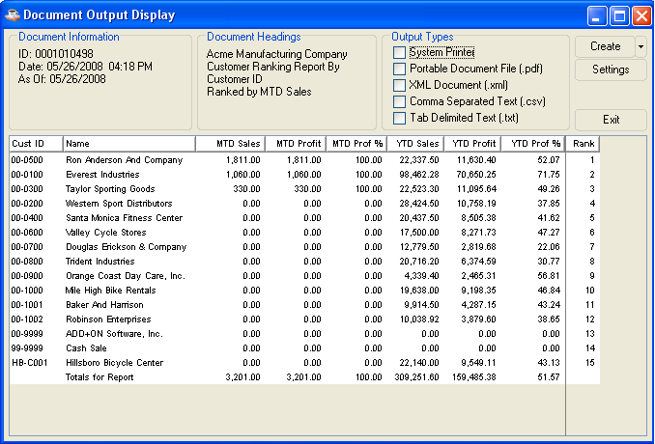

----------------------------------------Not Mentioned in Barista---------------------------------------------

Zero Balance Invoice Report and Purge
Based on an operator entered date, this task reads through the Accounts Receivable Open Invoice file and prints a report showing all invoices with a zero balance prior to purging. This task should be run as required to keep the open invoice file to a manageable size.

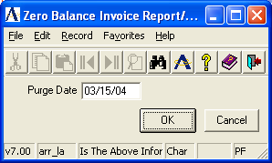

CAUTION: This task provides the capability to purge zero balance invoices as of any date. If you want to print customer statements showing payments made during the current month, do so before purging the current month’s activity.

In the Purge Date field...
• Enter the date through which all zero balance invoices are removed from the accounts receivable open invoice file.
-or-
Press F4 to return to the menu.

The following prompt is issued:

Is The Above Information Correct?

• Enter Yes to print a report showing all zero-balance invoices through the purge date.
-or-
Enter No when the purge date is incorrect.
-or-
Press F4 to return to the Period-End Processing Menu.

Printing
As the invoices are printed, progress is displayed on the screen.

When the invoices are printed, the following prompt is issued:

Are You Ready To Purge These Invoices?

• Enter Yes to purge the invoices shown on the register.
-or-
Enter No to return to the Period-End Processing Menu.

Updating
As the invoices are purged, progress is displayed on the screen. The invoice records including all related payments, and adjustment records are deleted from the file.

----------------------------------------Not Mentioned in Barista---------------------------------------------

Period-End Update
The Period-End Update closes the accounting period for the Accounts Receivable module. This process also initializes Sales Analysis for the next year when it runs for the last period of the fiscal year.

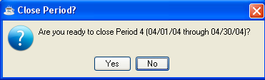

CAUTION: Be sure you have reviewed the steps required for period-end processing as outlined in the Flow of Processing section of this manual before proceeding with the update.

The following prompt is issued:

• Press Yes to begin the update.

- Press No to return Period End Update menu.

Updating
The update performs the following tasks:

1. The month-to-date sales and cost-of-sales figures in the Customer Masterfile are reset to zero. For the last period in the fiscal year, the year-to-date figures are moved to the prior year and the current year figures are set to zero.

2. Month-to-date sales register totals are cleared.

3. Month-to-date cash receipts totals are cleared.

4. Temporary customers (those with Retain set to N in their Customer Masterfile) not having any open invoices or credit balances are removed.

5. The current period indicator in the Accounts Receivable parameters is incremented. For the last period of the fiscal year, the current year indicator is incremented and the current period indicator is set to 1.

6. For the last period of the fiscal year, the Sales Analysis module’s files are initialized for the new year.

Accounts Receivable Maintenance
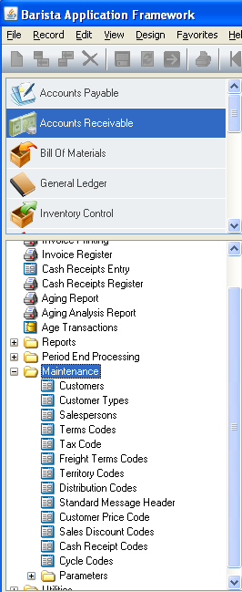
Accounts Receivable Maintenance Menu

Function
The Accounts Receivable Maintenance Menu provides access to the Customer Masterfile as well as the supporting codes used throughout the module. Maintenance of the Accounts Receivable parameters is also performed through this menu.

Shown above is the menu as it exists for the standard software. Your module may show a different list of tasks or the custom changes that were made depending on how it was installed.

n To access the Accounts Receivable Maintenance menu...

Select the Maintenance button after accessing Accounts Receivable.

About the Accounts Receivable Maintenance Menu Tasks
To access any task on this menu, click the appropriate tasks

Customer Maintenance
The Customer Maintenance task allows for the entry of new customers, maintenance of existing customers and access to the customer’s status and history.

When you first access this task, the cursor appears in the Customer ID field. Refer to Customer Number, in Customer Maintenance for information on entering a customer number.

The Customer Maintenance Tabs (Name and Address, Profile and Aging and Sales Summary) are displayed on the screen when a customer is selected for maintenance. Changes can only be made to the customer’s records by selecting tabs from this screen. The three tabs mentioned above are provided with different information regarding a customer.

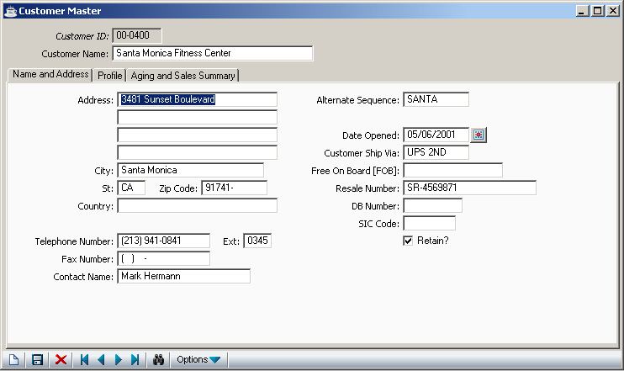

About the Customer Maintenance Options
The Customer Maintenance Option screen(Customer Master) allows you to work on one customer after another without ever leaving the Customer Maintenance task. Once a customer record is accessed, you can make adjustments. When you select a tab from the Customer Master screen, a set of fields prompts requiring your attention appear on the screen. After you have made changes, click the save button.

Customer Number
The Customer ID field prompts you to enter a valid customer number, where you can access one customer after another without leaving the Customer Maintenance task.

In the Customer No field...

• Enter the valid customer number
- if the customer number exists in the database the information regarding the particular customer will be displayed in the screen. You can search for a existing customer using Record Query button.
- When you enter a number that does not exist in the database, the fields will be blank, where you can enter the details regard the new customer. And the control advances to the customer name field.

In the Name field...

• Enter the name of the customer. (Length of this field ranges from 1 – 30)

NOTE: To delete a customer, enter the Customer ID and press enter. When the details are displayed click the delete button . Then the following screen prompts you to confirm deletion, click Yes to delete, No to return to the customer maintenance screen.

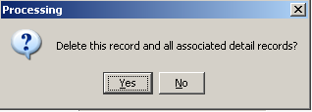

A customer may not be deleted if an accounts receivable balance exists.

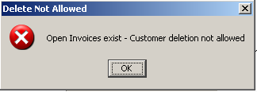

Automatic Customer Numbering
Optional
The Accounts Receivable module can provide for automatic sequential numbering for new customers. This offers a fast, controlled method of assigning numbers for new customers, as in the initial download to the computer.

If you press Return without entering any customer no in the Customer ID, the system prompts you whether to assign next Customer No automatically or not.

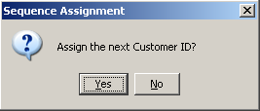

Click Yes to assign customer no automatically, click No to assign the customer no manually, and the control returns to the Customer ID field.

Name, Address & Profile Maintenance
The Name, Address & Profile option allows for the inquiry and change of the customer name and address, along with other information used by the Accounts Receivable and Order/Invoice Processing modules. It is also the option to use in removing customers from your system.

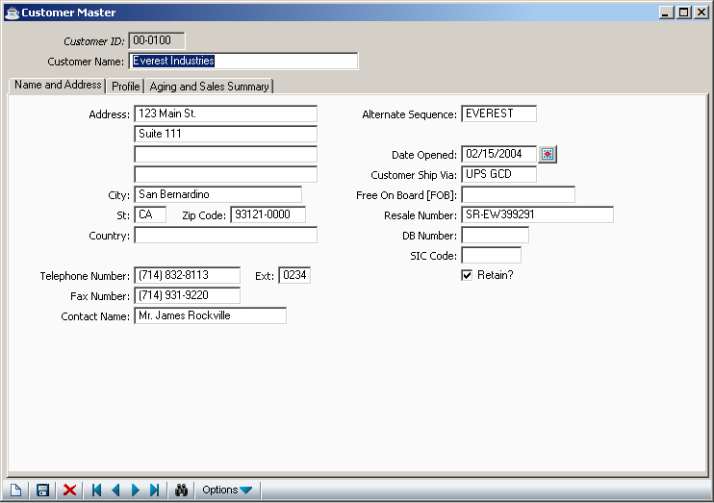

When entering a new customer, the fields in this option are blank. When an existing customer is accessed, all address information is displayed.

In the Name field...
• Enter a customer name of up to 30 characters.

In the Address field...
• Enter up to four lines (24 characters each) of customer address information.

In the City field...
- Enter up to 22 characters to identify the name of the city associated with the customer.

In the State field...
- Enter 2 characters to identify the name of the state associated with the customer.

In the Zip/Postal field...
• Enter the customer’s zip code.

Either a 5 or 9 digit zip code is requested, depending on how the parameter is set in Accounts Receivable Parameter Maintenance.

In the Country field...
• Enter up to 24 characters representing the name of the country associated with the customer.

In the Telephone field...
• Enter the customer’s telephone number with area code.

The punctuation for the area code and prefix are displayed automatically.

In the Ext field...
• Enter a telephone extension number, if applicable.

In the Fax Phone field...
- Enter a fax phone number , if applicable.

In the Contact field...
• Enter the name of the customer’s contact person up to 20 characters in length.
The first 10 characters in this name are used for searches of contacts.

In the Alt Seq field...
- Enter an alternate sequence for the customer up to 10 characters in length.

• The first 10 characters of the customer name will be automatically accepted
When using the Record Query buttonthis sequence is used to locate the customer by name. It is also used to sort customers alphabetically for reports. Generally, it is made up of the first 10 characters of the name; however, any name can be entered. For instance, you may want to enter AT&T for American Telephone and Telegraph.

In the Date Opened field...
- Enter the date that this customer was originally established.
- Click the Calendar button to display calendar, and select date
- Press Return to accept the terminal date.

This date can also be used to record when the customer was set up on the computer.

In the Ship-Via field...
• Enter the standard shipping method for this customer, up to 10 characters in length.

This becomes the default value used by the Order/Invoice Processing module.

In the FOB field...
- Enter up to 15 characters to identify the freight charge description.

In the Resale No field...
• Enter the customer’s resale identification number, if applicable.

In the D&B Number field…
- Enter the customer’s Dun & Bradstreet identification number.

In the SIC Code field…
- Enter the Standard Industry Code classification number for the customer.

In the Retain field...

• Uncheck the Retain box to indicate No to remove this customer during period-end processing when invoices do not exist.

• Check the Retain box to indicate Yes to retain this customer during the accounts receivable period-end processing, when the customer’s accounts receivable balance is zero.
- Press Return to leave blank and proceed to the next field.

The following prompt is issued:

- After filling all the mandatory fields in the Name & Address screen, click the save button .

- Click the New button to begin new Customer Maintenance:

If you attempt to leave an unsaved Customer Maintenance details by clicking New button, the module will issue a confirmation box as follows:

• Click Yes to save the current record and return to Customer ID field in the screen.
- Click No to return to the Customer ID field without saving the current record.

- Click Cancel or the Close Window button to return to the current Customer Maintenance Screen(Customer Master).

- Click the Delete button to remove the customer from the system. When any outstanding accounts receivable balance exists for the customer, the deletion request is ignored.

Profile Information
In addition to the standard name and address information, there are a number of file-verified fields that may be associated with a customer. These codes are generally used throughout the Order/Invoice Processing and Sales Analysis modules. During Order/Invoice Entry, they provide default values that speed the data entry process. The default values may always be overridden for a particular order or invoice.

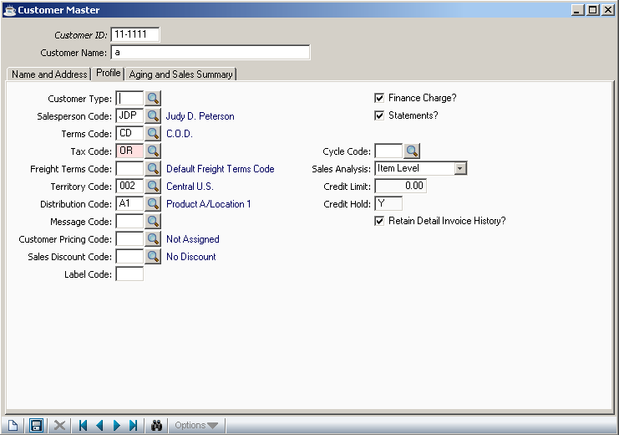

Not all of these fields may be applicable to your business (such as the Territory). However, you still must assign a code when setting up a customer. When this is the case, establish a single code (i.e., one named “Standard”) to apply to the entire customer base and enter that code for each customer.

You may also find that a file-verified field, when taken literally, may be used for another purpose depending on how it was installed. Study each of these codes and how they effect the module operation before you rule out their use. Familiarity with Order/Invoice Processing and Sales Analysis is helpful in making these determinations.

Example
The Territory Code provides a way to track customer sales by geographic location in the Sales Analysis module. When it is not applicable to your business, you may use the code to track sales by another category, such as customer account type (i.e. wholesale vs. retail).

In the Customer Type field...
• Enter a valid customer type as defined in the Customer Type Maintenance task.

- Click the Find button to select from a list of all valid types.

The customer type is used for sales analysis purposes. Each customer must be assigned a customer type, even when all customers are set up to be the same type.

In the Slsprsn No field...
• Enter a valid salesperson code as defined in the Salesperson Maintenance task.

- Click the Find button to select from a list of all valid salespersons.

The salesperson is used for reporting in this module and in the Order/Invoice Processing and Sales Analysis modules.

In the Terms Code field...
• Enter a valid terms code as defined in the Terms Code Maintenance task.

- Click the Find button to select from a list of all valid terms codes.

In the Tax Code field...
• Enter a valid sales tax code for the customer that is used by the Order/Invoice Processing module.

- Click the Find button to select from a list of all valid codes.

You must enter a tax code even when the customer is reselling merchandise. In this case, you should have a tax code with a zero percent and description of “Resale” or “Non-Taxable.”

Keep in mind that the tax code only specifies the tax jurisdiction for the customer. The actual application of sales tax during the Order/Invoice Entry process is also determined by the item being sold and order line type that have their own definition of taxability.

In the Freight Terms field...
- Enter a valid freight terms code.

- Click the Find button to select from a list of valid codes.

In the Territory field...
• Enter a valid territory code as defined in the Territory Code Maintenance task.

- Click the Find button to select from a list of all valid territory codes.

In the Dist Code field...
• Enter a valid distribution code.

- Click the Find button to select from a list of all valid distribution codes.

The distribution code provides the capability to associate a different account for receivable, sales tax, freight and optionally revenue, for each customer.

In the Cycle Code field...
• Enter a valid cycle code that determines when this customer will receive a statement.

- Click the Find button to select from a list of all valid codes.

In the Std Message field...
• Enter an optional standard message code that will appear on the customer’s invoice.
- Click the Find button to select from a list of all valid messages.

In the Customer Pricing Code field...
• Enter a valid price code as defined in the Price Code Maintenance task.
- Click the Find button to select from a list of all valid price codes.

The customer pricing code, in conjunction with an inventory item class code, identifies a quantity break table that is used to calculate prices during order and invoice entry.

When the Order/Invoice Processing module is not installed, this field is not applicable and may be left blank.

In the Sales Discount field...
• Enter a valid sales discount code as defined in the Sales Discount Code Maintenance task.
- Click the Find button to select from a list of all valid discounts.

The sales discount code allows you to provide a percentage discount on a customer’s entire invoice as entered through the Order/Invoice Processing module.

The sales discount is separate from the pricing method used to calculate sales prices on inventory items during the Order/Invoice Entry process.

In the Label Code field...
• Enter a two-character code used for selection purposes during Customer Label printing.

In the Finance Charge field...
• Enter Y if the customer is eligible for finance charges.
-or-
Enter N if this customer is not eligible for finance charges.
• Check the Finance Charge checkbox to indicate Yes if the customer is eligible for finance charges.
• Uncheck the Finance Charge checkbox to indicate No if this customer is not eligible for finance charges.

- Press Return to leave blank and proceed to the next field.

Finance charge calculations are made as a separate process, depending on a number of other accounts receivable criteria.

In the Statements field...
• Check the statement checkbox to indicate Yes when this customer is eligible to receive accounts receivable statements.
• Uncheck the statement check box to indicate No when the customer is not eligible to receive statements.

- Press Return to leave blank and proceed to the next field.

Other selection criterion is available at the time the statements are actually printed.

In the Cycle Code field...
- Enter the cycle code for this customer.

- Press Return to select all codes.

- Click the Find button to select from a list of all valid codes.

In the Sales Analysis field...

From the drop down list, select

- Product Level to summarize sales analysis for this customer on a product code level.
• Item Level to retain sales analysis for this customer by inventory item (most detailed).
• No Sales Analysis to not collect sales analysis data for this customer.

When the Sales Analysis module is installed, this field controls how sales analysis data is collected for this customer. However, the level of sales analysis detail is limited by the settings created in Sales Analysis Parameter Maintenance.

In the Credit Limit field...
This field is only accessible if Credit Management is not installed.
• Enter the maximum amount of credit to be extended this customer before a hold is placed on their account.

When Credit Management is installed, this field shows the credit limit placed on this customer in the Credit Manager’s Review & Release task in Order/Invoice Processing.

In the Credit Hold field...
This field is display only and appears only if the Credit Management system is installed.

A customer may be placed on credit hold for one of several reasons, depending partly on the setting of the Credit Management parameters. Credit holds may be placed automatically on any new customer or on one who has exceeded a credit limit. The credit manager may also manually apply a credit hold. Refer to Credit Management Parameters in the Installation section of the Order/Invoice Processing manual for further information.

In the Retain Detail History field...
• Check the Retain Detail checkbox to indicate Yes for each customer for whom invoice history is to be retained.
• Uncheck Retain Detail checkbox the check box to indicate No for each customer for whom invoice history is not to be retained.

- Press Return to leave blank and proceed to the next field.

The following prompt is issued:
- After filling all the mandatory fields in Profile, click save button
- Click the New button to begin new Profile of Customer Maintenance:

If you attempt to leave an unsaved Profile by clicking New button, the module will issue a confirmation box as follows:

• Click Yes to save the current record and return to Customer ID field in the screen.
- Click No to return to the Customer ID field without saving the current record.

- Click Cancel or the Close Window button to return to the current Profile screen of Customer Maintenance (Customer Master Screen).

Aging and Sales Summary
The Aging and Sales Summary option provides on-line inquiry into a customer’s accounts receivable balance, summarized aging, average days to pay and summarized sales and gross profit information. All fields are display only.

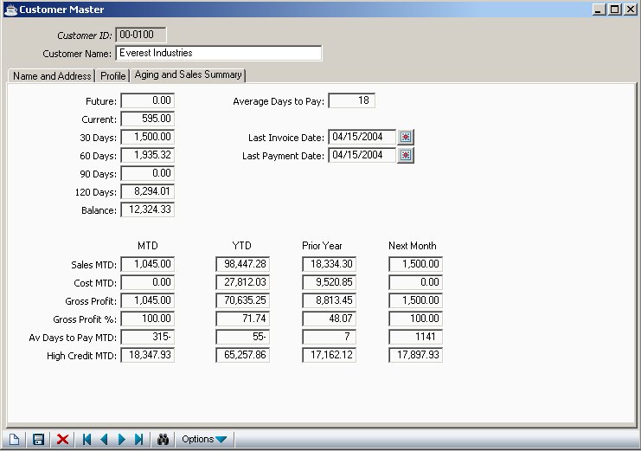

In the Future field...
Shows the amount of a customer’s open invoices with a due date beyond the current period. An amount will normally appear in the future if it is not yet due.

In the Current field...
Shows the amount of a customer’s open invoices with a due date from present to 29 days past due.
In the 30-days field...
Shows the amount of a customer’s open invoices with a past due date of 30 to 59 days.

In the 60-days field...
Shows the amount of a customer’s open invoices with past due dates from 60 to 89 days.

In the 90-days field...
Shows the amount of a customer’s open invoices with past due dates from 90 to 119 days.

In the 120-days field...
Shows the amount of a customer’s open invoices with past due dates over 120 days.

In the Balance field...
Shows the total amount due from this customer.

NOTE: The customer aging information is updated each time an accounts receivable aging or customer statement is printed, not as invoices and cash receipts are updated. Be sure to take this into account before making credit or collection decisions for a customer.

In the Avg Days To Pay field...
Shows the average number of days this customer took to pay since opening the account. This number is recalculated automatically during the Cash Receipts Update process by using the number of days between the invoice date and the cash receipts date for each of the customer’s invoices.

NOTE: The average number of days to pay does not take into account the terms of an invoice. Be sure to remember this when assessing a customer’s payment history.

In the Last Invoice Date field...
Shows the date of the last invoice updated to this customer’s account through the Order/Invoice Processing module.
In the Last Payment Date field...
Shows the date of the last payment posted to this customer’s account through the Cash Receipts Entry task. This date is the same as the Cash Receipts Register date recorded when the customer’s payment was received.

In the Mtd Sales, Cost, Gross Profit, Gross Profit %, Avg Days Pay and High Credit fields...
Shows month-to-date information for each of the categories. The sales figure does not include tax or freight and represents the gross amount of sales before any overall invoice discount is applied. This information is replaced by the next month figures as part of the Accounts Receivable Period-End update.

In the Ytd Sales, Cost, Gross Profit, Gross Profit %, Avg Days Pay and High Credit fields...
Shows year-to-date information for each of the categories. The year-to-date information also includes the month-to-date figures. Sales figures do not include tax or freight, and represent the gross amount of sales less any sales discount applied. This information is replaced by the next month figures as part of the Accounts Receivable Period-End update for the last period of the fiscal year.

In the Prior Year Sales, Cost, Gross Profit, Gross Profit %, Avg Days Pay and High Credit fields...
Shows prior year information for each of the categories. The prior year information represents the entire prior year, not prior year-to-date. Sales figures do not include tax or freight, and represent the gross amount of sales before any overall invoice discount is applied. This information is replaced by the year-to-date figures as part of the Accounts Receivable Period-End update for the last period of the fiscal year.

In the Next Month Sales, Cost, Gross Profit, Gross Profit %, Avg Days Pay and High Credit fields...
When data for the next month has been entered, these fields show the next-month-to-date information for each of the categories. The sales figure does not include tax or freight, and represents the gross amount of sales before any overall invoice discount is applied. This information is moved to the MTD column and reset to zero as part of the Accounts Receivable Period-End update.

The following prompt is issued:
- After filling all the mandatory fields in Profile, click save button

• Click Close Window button to exit to the Customer Maintenance Options menu.

Invoice Detail Inquiry
The Invoice Detail Inquiry shows a customer’s open invoice file containing a record of billings, payments, adjustments and finance charges. To access this option – Accounts Receivable – Maintenance – customers, then enter a valid customer number or select from the list of customers, then click .

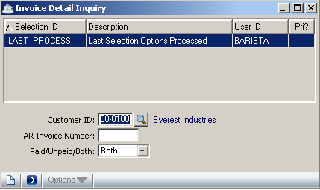

In the Customer ID field…

- Enter a valid customer number
- Click the Find button to select from a list of valid customers

AR Invoice Number field...

- Enter the invoice number you want to view.
- Leave this field blank to select all invoices

In the Display Paid, Unpaid Or Both field...
• Select Paid to view paid invoices only.

- Select Unpaid to view unpaid invoices only.

- Select both to view both types of invoices.

Click the Run Process button to generate report all invoices matching your criteria including invoice number, date created, date due, amount owed, etc. are displayed on the screen. Using the vertical scroll bar scroll or PgUp/PgDn keys, scroll through the invoices. When all invoices are displayed/viewed, click the Close Window button at any time, to return to the Customer Maintenance Screen

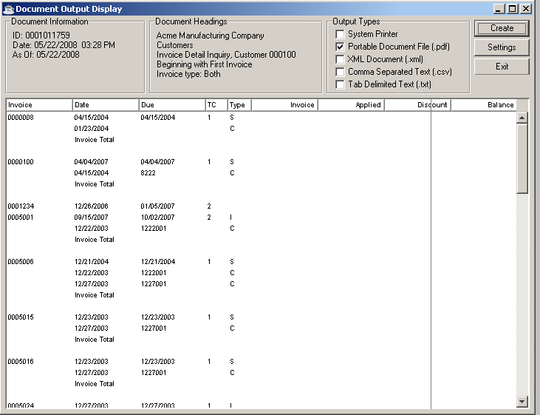

In the report shown above the following columns are displayed

- Invoice Invoice Number

- Date Invoice Date

- Due Shows the invoice due date, as determined by the terms code that was associated with the invoice

- TC Shows the terms code associated with the invoice

- Type Indicates the type of transaction
S Regular sale
R Return sale (conversion invoices only)
F Finance charge invoice
C Payment (Check)
- Invoice Shows the original amount due on the invoice

- Applied Shows the amount of payment (or credit) applied to this invoice

- •Discount Shows the amount of discount that is available for this invoice

- Balance Shows the balance due on the invoice

Ship-To Address Maintenance
The Ship-To Address Maintenance option allows for definition, maintenance and deletion of alternate customer ship-to information. The Order/Invoice Processing module uses this information to speed the handling of orders for customers with multiple locations. Up to 999,999 different ship-to addresses can be used.

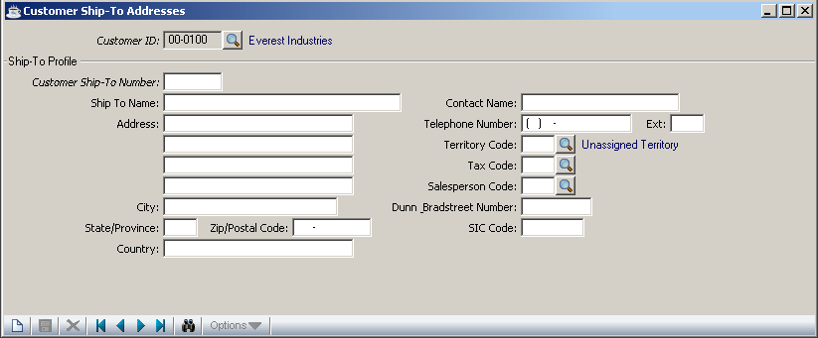

In the Customer Ship-To No field...
• Enter a unique sequence number for the customer’s alternate ship-to address.
- Click Record Query buttonto select from a list of all valid numbers.

- Click the Close Window button to return to the Customer Maintenance Options menu.

Note: Avoid using ‘99’ for the ship-to number. The Order/Invoice Processing module uses ‘99’ to identify a custom or manual ship-to address so it will not be accepted here.

If the Customer Ship-To-Number entered exists in the system, information on the address is displayed, if not found the cursor advances to the Ship-To-Name field

In the Ship-To Name field...
• Enter a name for the business of the Ship-To No.

In the Address field...
• Enter up to five lines to identify the ship-to address.

In the City field...
- Enter up to 22 characters to identify the name of the city associated with the customer.

In the State field...
- Enter 2 characters to identify the name of the state associated with the customer.

In the Zip/Postal field...
• Enter the zip code for the address, with a 4-digit extension if available.

In the Country field...
- Enter up to 22 characters to identify the name of the city associated with the customer.

In the Contact field...
• Enter up to 22 characters for the name of the contact person or department at this location.

In the Telephone field...
• Enter the telephone number, with area code of the ship-to address.

In the Ext field...
• Enter up to four characters for the phone number extension, if applicable.

In the Salesperson field...
• Enter a valid salesperson code.

- Click the Find button to select from a list of all valid salesperson codes.

In the Territory field...
• Enter a valid territory code.

- Click the Find button to select from a list of all valid territory codes.

In the Tax Code field...
• Enter a valid tax code.

- Click the Find button to select from a list of all valid tax codes.

In the D& B Number field…
- Enter the Dunn and Bradstreet number.

In the SIC Code field…
- Enter the Standard Industry Code.

The following prompt is issued:
- After filling all the mandatory fields in the Customer Ship-To Address screen, click save button .

- Click the New button to begin new Customer Ship-To Address:

If you attempt to leave an unsaved Customer Ship-To Address details by clicking New button, the module will issue a confirmation box as follows:

• Click Yes to save the current record and return to Customer Ship-To Number field in the screen.
- Click No to return to the Customer Ship-To Number field without saving the current record.
- Click Cancel or the Close Window button to return to the current Customer Ship-To Address Screen.
- Click the Delete button to remove this ship-to file address.

Hard Copy Printing
The Hard Copy Printing task prints a listing of all customer information for the selected customer. All information, including detailed receivable information, is included. This option is helpful during the data conversion process because it allows you to verify the customer information immediately after it is entered. The output is designed to fit on standard 8-1/2 by 11”computer paper. To access this option select Customer Detail Listing from the reports menu. When this option is select a screen appears prompting you to select the desired customer.

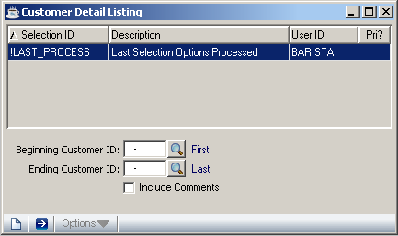

The Beginning Customer and Ending Customer can be selected by clicking the Find button or entering a valid customer number. If the two fields are left blank, all the customers will be selected for printing. Click the Run Process button to start generating report.

Printing
The report can be directly passed to a printer or can be converted to a Portable Document File (pdf).

Comment Maintenance
Comment Maintenance allows for the creation, modification, deletion, inquiry and listing of customer comment information.

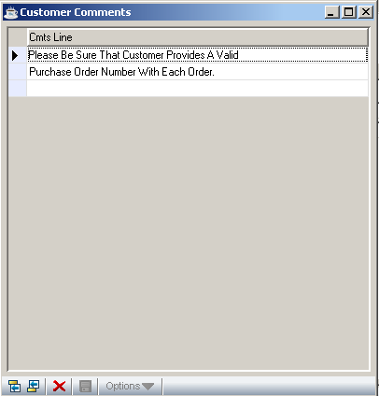

In the Comment Line(Cmts Line) field...
• Enter any comment of up to 48 characters in length.

• Use the Vertical Scroll Bar or PgUp/PgDn keys to view several pages of comments.
- Click the Add to End button to add new comments
- Click the Insert Before button to insert a comment
- Click the Delete Current Record button to delete the selected comment
- Double click on a comment for modification

Order/Invoice History Inquiry
When the Order/Invoice Processing module is installed, this option allows inquiry into a customer’s open orders in either a summarized or detailed format. Summarized orders display the order number, type, order date, ship date, PO number, ship-via, salesperson invoice number and the order total. Additionally, the detailed format displays the item description with lot number, warehouse, quantity, price, etc.

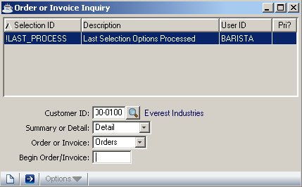

In the Customer ID field...
- Enter a valid customer number
- Click the find button to select from a list of valid customers.

In the Summary or Detail field...
• Select Summary to display all of the customer’s open orders in summary format, one line per order.
• Select Detail to display the detail line items on a specific order.

In the Order or Invoices field…
• Select Order to display all orders for the customer
• Select Invoice to display all invoices for the customer

In the Beginning Order field...
• Enter a valid Order/Invoice number for this customer.
• Leave this field blank to display all Open Orders/Invoices for the customer.

The following prompt is issued:

• Click the Run Process button when all information is correct and proceed Customer report(order or invoice inquiry).

- Click the New button to begin new Customer (order or invoice inquiry).

If you attempt to leave an unsaved Customer (order or invoice inquiry) by clicking New button, the module will issue a confirmation box as follows:

- Click Yes to save the current record and proceed with Customer report(order or invoice inquiry).
- Click No to return to the Customer ID field in Order or Invoice inquiry form
without saving the record.
- Click Cancel or the Close Window button to return to current Order or Invoice inquiry form in Customers

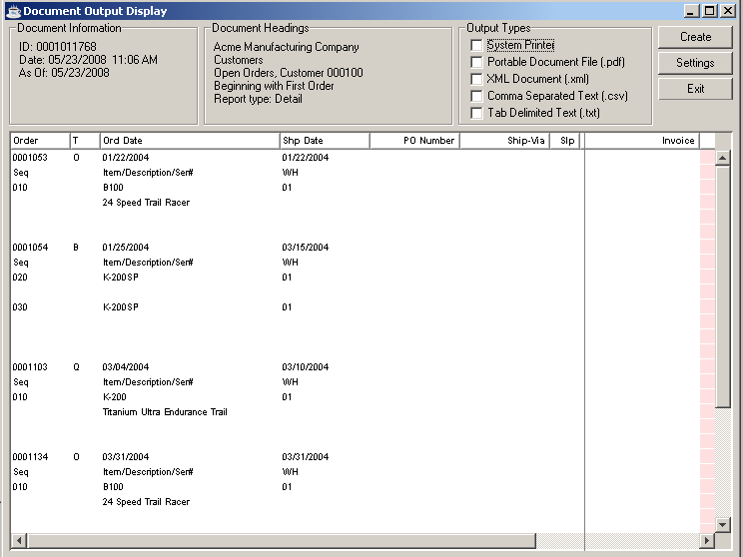

---------------------------------------------Barista Problem-------------------------------------------------

While selecting the Invoice Option, an error occurs and the program hangs.
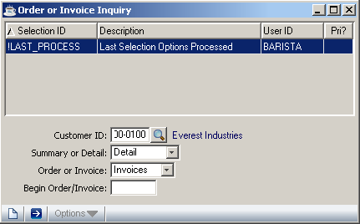
---------------------------------------------Barista Problem-------------------------------------------------

Customer Type Maintenance
The Customer Type Maintenance task allows for the creation, modification, deletion, inquiry, and listing of customer type codes used by the Order/Invoice Processing and Sales Analysis modules.

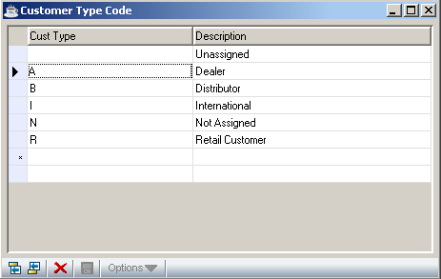

Each customer is assigned a customer type that is entered in Customer Maintenance. Customer types are used by the Sales Analysis module to record sales history by customer type and product code.

To select the customer type double-click the appropriate description

In the Customer Type field...
• Enter a customer type code of up to three characters in length.

In the Description field...
• Enter up to 20 characters to describe the customer type.

To add/change/delete customer types, follow these steps:

• Click the Add to End button to add a new customer type
• Click the Insert Before button to insert a new customer type
• Click the Delete button to delete the selected customer type
• Double-click the appropriate description to make changes
• Select a record and click the Expand button to make changes in description.

While creating a new customer type duplicate codes are not allowed, enter the code and description of the new customer type and click the save button:

Salesperson Maintenance
The Salesperson Maintenance task allows for the creation, modification, deletion, inquiry and listing of salesperson codes used by the Order/Invoice Processing and Sales Analysis modules.

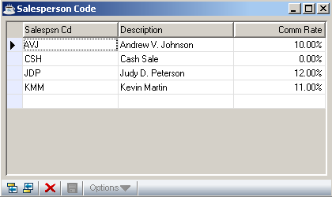

In the Salesperson field...
• Enter a 3-character salesperson code.

In the Name field...
• Enter up to 20 characters for the name of this salesperson.

In the Comm Rate field...
• Enter a number that represents the commission rate for this salesperson.

Example
Enter 5.5 to represent a commission of 5.5% (.055).
When you finish with the entries to the fields, click the save button .

To add/change/delete salesperson types, take the following steps:

- Click the Add to End button to add a new salesperson type
- Click the Insert Before button to insert a new salesperson type
- Click the Delete button to delete the selected salesperson type
- Double-click the appropriate description to make changes.
- Select a record and click the Expand button to make changes in description and Comm Rate.

Terms Code Maintenance
The Terms Code Maintenance task allows for the creation, modification, deletion, inquiry and listing of terms codes used in Order/Invoice Processing, Conversion Invoice Entry, Simple Invoice Entry and Cash Receipts.

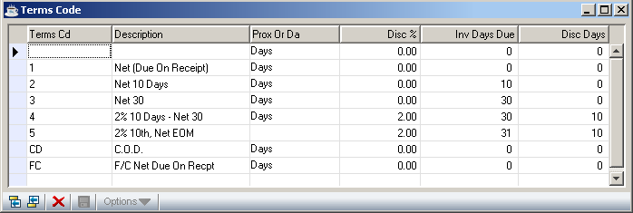

Once established, terms codes are associated with each customer record. When a terms code is used, its definition will automatically determine an invoice due date and discount due date, if applicable.

When the terms code is set up, it will automatically display.

In the Terms Code(Tems Cd) field...
• Enter a terms code of up to 2-characters.

In the Description field...
• Enter up to 20 characters to describe the terms.

In the Prox or Day(Prox Or Da) field...
• Select Day or Prox by double clicking this field.
• Day terms based on a specific number of days from the invoice date
• Prox terms based on a specific day in the next month.

In the Discount %(Disc%) field...
• Enter a number that represents the discount rate available for these terms.

If no discount is offered, enter 0.

Example
Enter 2.5 to represent a prompt payment discount of 2.5% (.025).

In the Inv Day(s) Due field...
• Enter the number of days past the invoice date when the total amount of the invoice is due after you select Day in the Prox or Day field.
• Enter the invoice due date of the next month (1 through 31) by selecting Prox in the Prox or Day field. For prox terms, enter 31 to represent the last day of the following month.

In the Discount Days(Disc Days) field...
• Enter the number of days past the invoice date when a prompt payment discount may be taken by selecting Day in the Prox or Day field.
• Enter the day of the month to take a prompt payment discount when Prox is selected in the Prox or Day field. For prox terms, the discount date is always the day of the following month.

To add/change/delete terms codes, take the following steps:

• Click the Add to End button to add a new terms code
• Click the Insert Before button to insert a new terms code
• Click the Delete button to delete the selected terms code
• Double-click the appropriate description, Prox or Da, Disc %, Inv Days Due, Disc Days etc. to make changes, Terms code is not allowed to modify
• Select a record and click the Expand button to make changes in appropriate description, Prox or Da, Disc %, Inv Days Due, Disc Days.

Terms Codes Examples

Example 1: Example 2:
Invoice is due when it is Invoice is due 30 days
created - no discount is from invoice date - no
offered. discount is offered.

Code: 00 Code: 30
Description: Due on Receipt Description: Net 30 Days
Type: D Type: D
Discount: 0.0% Discount: 0.0%
Net Day(s): 00 Net Day(s): 30
Discount Days: 0 Discount Days: 0
Credit Hold: N Credit Hold: N

Example 3: Example 4:
Invoice is due 30 days after Invoice is due at the
created - a 2% early payment may end of the month after discount taken if the payment is was created.
received within 10 days.

Code: 10 Code: 31
Description: 2% 10 Net 30 Description: Net EOM
Type: D Type: P
Discount: 2.0% Discount: 0.0%
Net Day(s): 30 Net Day(s): 31
Discount Days: 10 Discount Days: 0
Credit Hold: N Credit Hold: N

Example 5: Example 6:
Invoice is due at the end of Cash on delivery - as
the month after it is created. may apply to a will call
A 2% discount may be taken sale or C.O.D. delivery.
if payment is received by the
10th of the following month.

Code: 11 Code: CD
Description: 2% 10th Net EOM Description: C.O.D.
Type: P Type: D
Discount: 2.0% Discount: 0.0%
Net Days(s): 31 Net Day(s): 0
Discount Days: 10 Discount Days: 0
Credit Hold: N Credit Hold: N

Tax Code Maintenance
The Tax Code Maintenance task allows for the creation, modification, deletion of Tax Codes.

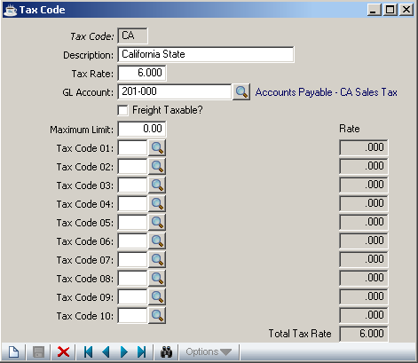

In the Tax Code field…
- Enter a two character code, if the codes exists in the system the details, description, tax rate and GL Account, are displayed, otherwise the fields will be blank and new details can be entered.
- Use the record query button to select from a list of valid codes

In the Description field…
- Enter description upto 20 characters in length

In the Tax Rate field…
- Enter a number to indicate the tax rate (percentage)

In the GLAccount field …
- Enter a valid GL Account number
- Click the find button to select from a list of valid Gl Account codes

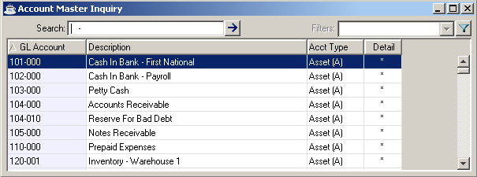

In the Freight Taxable field…

- Click the Freight Taxable CheckBox to indicate Yes
- Leave the Check Box Blank to indicate No

In the Maximum Limit field…

- Enter an amount to set the limit of the tax

In the Tax Code 01 to Tax Code 10 fields…

- Enter Valid tax code, the rate of tax will be displayed in the rate field against each tax code field
- Click the find button to select from a list of valid tax codes

In the Total Tax Rate field…
- The total tax rate is displayed in this field, when the fields Tax Code 01 to Tax Code 10 are filled.

Click the save button to save details.

If you attempt to leave an unsaved Tax Code by clicking New or Close Window, the module will issue a confirmation box as follows:

- Click Yes to save the current record and return to the Tax Code field in the form.
- Click No to return to the Tax Code field without saving the current record.
- Click Cancel or the Close Window button to return to the current Tax Code Screen

Freight Terms Code
The Freight Terms Code Maintenance allows for the creation, modification, deletion, inquiry and listing of freight terms codes.used in Order/Invoice Processing and Sales Analysis modules.

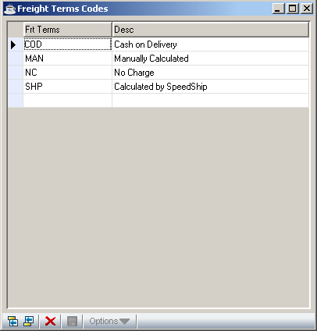

In the Frt Terms field…
- Enter a 3 character code
In the Description field…
- Enter description up to 20 characters

Click the save button to save the new freight terms code.

To add/change/delete freight terms code, take the following steps:

• Click the Add to End button to add a new freight terms code
• Click the Insert Before button to insert a new freight terms code
• Click the Delete button to delete the selected freight terms code

• Double-click the appropriate description to make changes, Duplicate Freight code is not allowed
• Select the record and click the Expand Record button to make the changes in corresponding description.

Territory Code Maintenance
The Territory Code Maintenance task allows for the creation, modification, deletion, inquiry and listing of territory codes used in the Order/Invoice Processing and Sales Analysis modules. Territory codes can also be used for setting a range for printing customer statements.

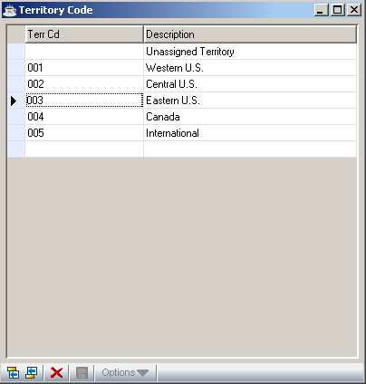

Once established, territory codes are associated with each customer record and become part of the order/invoice heading information. If your business does not have distinct sales territories, you must set up at least one territory code that is used by all customers.

In the Territory Code field...
• Enter a 3-character territory code.

In the Description field...
• Enter up to 20 characters to describe the territory.

To add/change/delete territory codes, take the following steps:

• Click the Add to End button to add a new territory code
• Click the Insert Before button to insert a new territory code
• Click the Delete button to delete the selected territory code
• Double-click the appropriate description to make changes, Territory code is not allowed to modify
• Select a record and click the Expand button to make changes in description.

Distribution Code Maintenance
The Distribution Code Maintenance allows for the creation, modification, deletion, inquiry and listing of distribution codes used to determine general ledger postings during the Accounts Receivable billing and Order/Invoice entry functions.

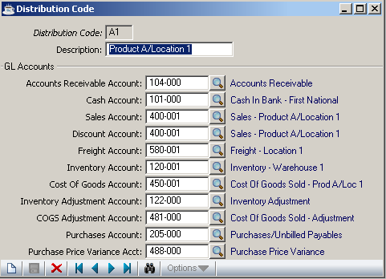

Distribution codes are assigned directly to customers in the Customer Masterfile and optionally, in the Inventory Item Masterfile. This allows you to associate multiple receivable accounts with the customer base, if desired.

In the Distribution field...
• Enter a 2-character alphanumeric distribution code.
- Click the Record Query button to select from a list of valid codes

When the distribution code is set up, the distribution code information is displayed. If the distribution code does not exist, it will be treated as a new code and the fields below will be blank for the user to enter or select from the list available.

In the Description field...
• Enter up to 20 characters to describe this cash receipts code.

In the Account Receivable Account field...
• Enter a valid general ledger account number.
- Click the find button to select from a list of valid account numbers.

This account will normally be the simple invoices and invoices generated by the Order/Invoice Processing module. Also, remember that the General Ledger module must be installed to access the GL account fields.

In the Cash Account field... accounts receivable control account that is debited during the update process for conversion invoices…
• Enter a valid general ledger account.
- Click the find button to select from a list of valid account numbers.

This account is used in posting cash sales transactions generated by the Order/Invoice Processing module.

In the Sales Accountt field...
• Enter a valid general ledger account number.
- Click the find button to select from a list of valid account numbers.

This account is used in posting revenue to the general ledger.

NOTE: When the Order/Invoice Processing and Inventory Control modules are installed, the selection of a distribution code for revenue posting is dependent on the Distribute Sales By Item parameter in the Accounts Receivable Parameter Maintenance task. If this parameter is set to Y, the revenue accounts are determined by the distribution code associated with each inventory item. If the parameter is set to N, these accounts are taken from the distribution code that is associated with the customer, which becomes the default value for the Order/Invoice header.

In the Discount Account field...
• Enter a valid general ledger account number to post allowed discounts.
- Click the find button to select from a list of valid account numbers.

NOTE: This account is used for sales discounts; it is not used for terms discounts. It will also post transactions to the discounts allowed, where the posting amount is taken from the overall invoice discount that is available in the Order/Invoice Processing module.

In the Freight Account field...
• Enter a valid general ledger account number.
- Click the find button to select from a list of valid account numbers.

This account is used in posting freight revenue that is entered on invoices generated by the Order/Invoice Processing module.

In the Inventory Account field...
• Enter a valid general ledger account number.
- Click the find button to select from a list of valid account numbers.

This account is used in posting transactions to an inventory asset account. This is applicable only to invoices generated by the Order/Invoice Processing module.

In the Cost Of Goods Account field...
• Enter a valid general ledger account number.
• Click the find button to select from a list of valid account numbers.

This is applicable only to invoices generated by the Order/Invoice Processing module.

In the Inventory Adjustment Account field…
- Enter a valid general ledger account number.
• Click the find button to select from a list of valid account numbers.

This account is used to record adjusting transactions rather than posting them directly to an inventory account. The Inventory Adjustment Transaction is an example of its use. This is a contra asset account.

In the COGS Adjustment Account field…
- Enter a valid general ledger account number.
• Click the find button to select from a list of valid account numbers.

This account is used to record adjusting transactions rather than posting them directly to a cost of goods sold account. This is an expense account.

In the Purchases Account field…
- Enter a valid general ledger account number.
• Click the find button to select from a list of valid account numbers.

This account is used to record the value of incoming Purchase Orders that were received and no vendor invoice was issued. This is an asset account.

In the Purchase Price Variance Account field…
- Enter a valid general ledger account number.
• Click the find button to select from a list of valid account numbers.

This account is used to accumulate the differences in the cost of items from vendors. This is an expense account.

When the fields are setup with appropriate account numbers, click the save button .
- Click the New button to begin new Distribution Code.

If you attempt to leave an unsaved Distribution Code by clicking New button, the module will issue a confirmation box as follows:

- Click Yes to save the current record.The form is cleared in preparation for another Distribution Code entry.
- Click No to return to Distribution Code field in the form without saving the record.
- Click Cancel or the Close Window button to return to the current Distribution Code form.

Standard Message Header
The Standard Message Header Maintenance allows for the creation, modification, deletion, of standard messages. When you select this option the screen will be blank, where you can define new standard message header.

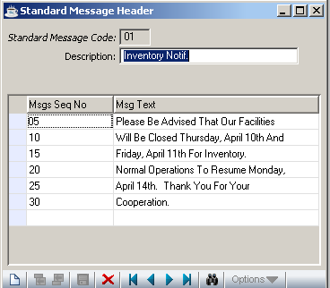

- Click the record query button to select from a list of valid standard message header. The message sequence no and the message text will be displayed below the code and description. You can modify the message text and sequence no by double clicking the appropriate record. If the code does not exists in the system the fields will be empty.

In the Msgs Seq No field…
- Enter a two character code

In the Description field…
- Enter description upto 20 characters

In the Msgs Seq No field …
- Enter 2 character code

In the Msg Text field …
- Enter upto 40 characters

Click the save button to save the new Standard Message Header

To add/change/delete Standard Message Header, take the following steps:

- Click the Add to End button to add a new Message sequence no and text
- Click the Insert Before button to insert a new Message sequence no and text
- Click the Delete button to delete the selected Standard Message
- Click the new button to begin a new Standard Message Header

If you attempt to leave an unsaved message header by clicking New or Close Window, the module will issue a confirmation box as follows:

- Click Yes to save the current record and return to standard message code field.
- Click No to return to the standard message code field without saving the current record.
- Click Cancel or the Close Window button to return to the current standard Message Header Entry Screen

Customer Price Code
The Customer Price Code Maintenance allows for the creation, modification, deletion, inquiry and listing of Customer Price code.

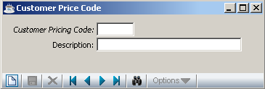

Customer Pricing Code field…

- Enter a customer pricing code upto 4 characters
- Click the record query button to select from a list of valid codes

Description field…
Enter description up to 20 characters in length

The following prompt is issued:

- Click the save button to save the new customer price code
- Click the delete button to remove the selected record
- Click the new button to add new customer price code

If you attempt to leave an unsaved customer price code by clicking New or Close Window, the module will issue a confirmation box as follows:

• Click Yes to save the current record and return to customer price code field.
- Click No to return to the customer price code field without saving the current record.
- Click Cancel or the Close Window button to return to the current customer price code Screen

Sale Discount Code

The Sale Discount Code Maintenance allows for the creation, modification, deletion, inquiry and listing of Sale Discount code.

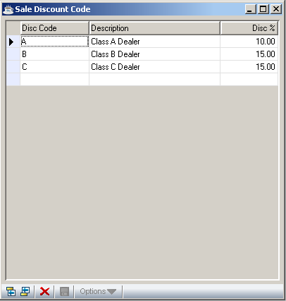

In the Disc Code field…
- Enter a code two characters in length

In the Description field…
- Enter description upto 20 characters in length

In the Disc % field…

- Enter the discount percentage

To add/change/delete sale discount code, take the following steps:

- Click the Add to End button to add a new sale discount code
- Click the Insert Before button to insert a new sale discount code
- Click the Delete button to delete the selected sale discount code

- Double-click the appropriate description and disc % to make changes. Duplicate code not allowed

Cash Receipts Code Maintenance
The Cash Receipts Code Maintenance task allows for the creation, modification, deletion, inquiry and listing of cash receipts codes used in Cash Receipts Entry. Cash Receipt Codes are used to identify bank accounts, type of payment and the source of payment or adjustment entries.

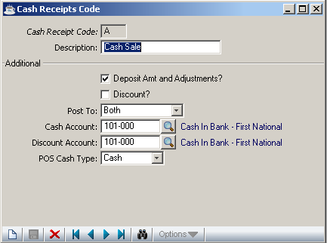

In the Code field...
• Enter a cash receipts code of up to 3 characters in length.
- Click the record query button to select from a list of all cash receipt codes
- Click the Close Window button to return to the menu.

In the Description field...
• Enter up to 20 characters to describe this cash receipts code.

In the Deposit Amt and Adjustments field...
- Click Deposit Amt and Adjustments checkbox to indicate Yes to include adjustments and deposit amounts during the cash receipts data entry.
- Leave the checkbox blank to indicate No

In the Discount field...

- Click the Discount checkbox to indicate Yes to allow discounts to be taken with this code during Cash Receipts Entry.
- Leave the check blank to indicate No

In the Post to field...
- Select Accts Receivable to post these receipts to accounts receivable invoices.
- Select General Ledger to post these receipts to general ledger accounts.
- Select Both to allow both.

In the Cash Account field with GL installed...
• Enter a valid general ledger cash account.
• Click the find button to select from a list of all valid accounts.

Post the cash amount to this account during the Cash Receipts Update. When depositing into several accounts, create a cash receipt code for each account.

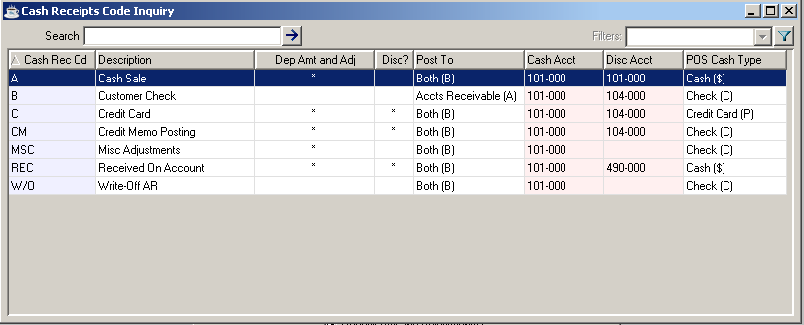

In the Discount Account field with GL installed...
You must answer Yes in the Discount field in order for this field to be activated.
• Enter a valid general ledger account to post allowed discounts.
• Click the find button to select from a list of all valid accounts.

Post terms discount amounts to this account when they are taken by a customer. This account is normally a contra-revenue account posted as a debit amount as part of the Cash Receipts Update process.

In the POS Cash Type field with OP installed...
• Select Cash for cash point-of-sale transactions.
• Select Check for check point-of-sale transactions.
• Select Credit Card for credit card point-of-sale transactions.

This field is not used by the cash receipts processing in the Accounts Receivable module, though a value must still be entered. The POS Cash Type is used by the Order/Invoice Processing to process point-of-sale invoices. The value entered causes a related set of questions to be asked on the total screen of the Simple Invoice Entry task.

The following prompt is issued:

Click the save button to save the new Cash Receipts Code
Click the delete button to remove the currently selected Cash Receipts Code

- Click the New button to begin new Cash Receipts Codes.

If you attempt to leave an unsaved Cash Receipts Codes by clicking New button, the module will issue a confirmation box as follows:

- Click Yes to save the current record.The form is cleared in preparation for another entry.
- Click No to return to the Cash Receipts Code field in the form without saving the record.
- Click Cancel or the Close Window button to return to the current Cash Receipts Code form

Cycle Code Maintenance
The Cycle Code feature enables your customer base to be divided into separate groups. This allows statements to be sent out over the course of the month in a staggered manner, rather than mailing all customer statements at the same time which can be problematic depending on the size of your customer base.

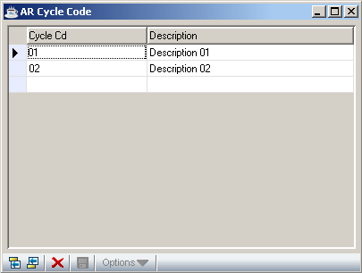

In the Cycle Code field...
• Enter a 2-character cycle code.

In the Description field...
• Enter up to 20 characters to describe the code.

The following prompt is issued:

- Click the save button to save the new AR Cycle Code.

To add/change/delete Cycle codes, take the following steps:

- Click the Add to End button to add a new cycle code
- Click the Insert Before button to insert a new cycle code
- Click the Delete button to delete the selected cycle code
- Double-click the appropriate description to make changes, Cycle code is not allowed to modify
- Select a record and click the Expand button to make changes in description.

Accounts Receivable Parameter Maintenance
The Accounts Receivable Parameter Maintenance task allows for the creation, modification, deletion and inquiry of the Accounts Receivable module parameters. In this task, you can tailor the Accounts Receivable module to the way you do business. The options presented here may be changed at a later date. Consult with your AddonSoftware Dealer before making any changes after your module is in operation.

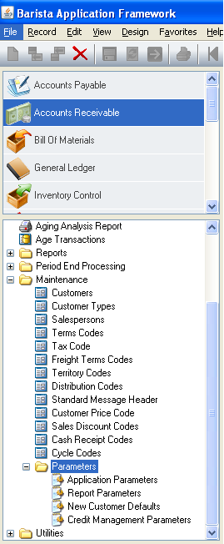

About the AR Parameter Maintenance Menu Options
The Accounts Receivable Parameter Maintenance Option Menu allows you to work on one parameter after another without ever leaving the Accounts Receivable Parameter Maintenance task. Once a parameter option is chosen, you can make adjustments to the settings. When you select an option from the menu, the list of options disappears from the screen and the parameter fields of the option you selected are displayed on the screen.

Application Parameters
Use this option to set the parameters system wide for the selected company.

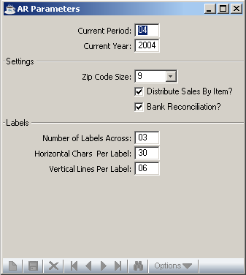

When you select this option, all existing parameters are displayed and the user can change the current setting and click the save button .
Click the delete button to remove the parameter from the file.

In the Current Period field...
• Enter the current Accounts Receivable period.

Enter a number between 1 and 13, which represents the current period of operation. The period indicator is automatically incremented as part of the Accounts Receivable Period-End process. The current period indicator is independent of the current period indicator in the General Ledger module.

Once a system is operational, you should consult your dealer and discuss the ramifications before making any changes to this field.

In the Current Year field...
• Enter the current fiscal year.

Use the calendar year in which the first fiscal period ends. It is incremented automatically when the period-end update is run for the last period of the fiscal year.

In the Zip/Postal Code Size field...
• Select 5 to set a zip/postal code parameter without the four-digit extension.

- Select 9 to set a zip/postal code parameter with an extension.

The parameter may be changed from 5 to 9 at a later time; however, you should not change from 9 to 5.

In the Distribute Sales By Item field ...
• Click the Distribute Sales By Item checkbox to indiciate Yes for general ledger distribution by inventory items.
• Uncheck or leave the Distribute Sales By Item checkbox blank to indicate No for general ledger distribution by customer.

This parameter allows you to control the method by which general ledger revenue accounts are posted during the invoice update process in the Order/Invoice Processing module. With inventory items (Yes option, checkbox clicked), the revenue account is taken directly from a distribution code associated with each inventory item on the invoice. The distribution code contains all of the necessary inventory detail information. However, when selecting the No option(checkbox blank), the revenue account is taken from the distribution code associated with a customer (which may be overridden at Order/Invoice Entry time). Because the customer distribution code does not contain the necessary inventory detail information, you must also enter general ledger accounts in Item Maintenance. This parameter has no effect on the general ledger postings made during Conversion Invoice processing or Simple Invoice processing.

In the Bank Reconciliation field ...
- Click on the Bank Reconciliation checkbox to indicate Yes to use bank reconciliation to update deposits.
- Uncheck or leave blank the Bank Reconciliation checkbox to indicate No

In the Number of Labels Across field...
• Enter a number from 1-4 that determines how many mailing labels are printed across the page.

In the Horizontal Chars Per Label field...
• Enter the width of the label.

This is the number of characters between the start of the first label across and the start of the second label across. Thirty-six (36) characters is standard for 1, 2, and 3 labels up. Thirty (30) characters are standard for 4 labels up.

In the Vertical Lines Per Label field...
• Enter the number of print lines between the top of the first label and the top of the next label down. Six (6) lines are standard.

Report Parameters
Report Parameters are used to define the company name and address for printing on the Simple Invoice forms. This screen consists of two tabs Reports & Remit To

a. Report Screen

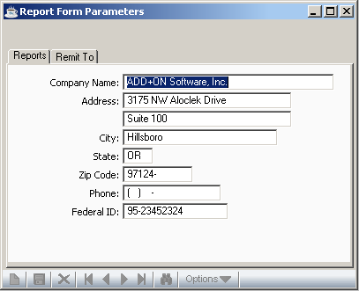

When you select this option, all existing parameters are displayed , the existing parameters can be modified and saved by clicking the save button .

In the Company Name field...
• Enter the company name using up to 30 characters.

This is the name of your company used for tax reporting purposes.

In the Address field...
• Enter an address of up to 3 lines and 24 characters per line.

This is the address of your company, as you would like it to appear on the simple invoices.

In the City field...
- Enter the name of the city using up to 22 characters.

In the State field...
- Enter the name of the state using 2 characters.

In the Zip Code field...
- Enter the zip code using 9 characters

In the Telephone Number field…
- Enter the customer’s telephone number. This telephone number will not print on the invoice.

In the Federal ID field...
• Enter the company’s federal ID with up to 15 characters.

This is the employer identification number used for tax reporting purposes. This information does not print on the invoice.

b. Remit To Screen

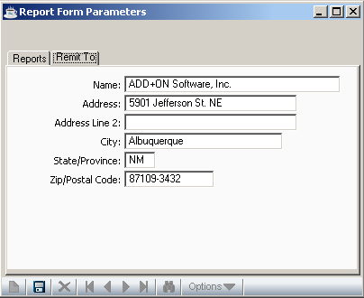

In the Name field...
• Enter the company name using up to 30 characters.

This is the name of the company to remit reports.

In the Address field...
• Enter an address of up to 2 lines and 24 characters per line.

This is the address of the company

In the City field...
- Enter the name of the city using up to 22 characters.

In the State/Province field...
- Enter the name of the state using 2 characters.

In the Zip/Postal Code field...
- Enter the zip code using 9 characters

New Customer Defaults
When a new customer is entered in the Accounts Receivable Customer Maintenance task, new customer default information is displayed. This standard sales information, common to the majority of your sales orders and invoices, can be overridden as desired.

NOTE: New Customer Defaults in the AR module is for permanent customers, while the New Customer Defaults task in Order/Invoice Processing is designed for temporary customers.

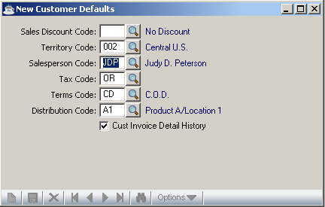

In the Sale Discount field...
• Enter a valid sale discount code.
- Click the find button to select from a list of valid discount codes

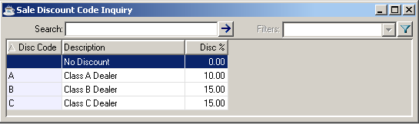

In the Territory field...
• Enter a valid territory code.
- Click the find button to select from a list of valid Territory codes

- Press Return to accept the default.

In the Salesperson field...
• Enter a valid salesperson code.
- Click the find button to select from a list of valid Salesperson discount codes

- Press Return to accept the default.

In the Tax Code field...
• Enter a valid tax code.
• Click the find button to select from a list of valid Tax codes

- Press Return to accept the default.

In the Terms Code field...
• Enter a valid terms code.
• Click the find button to select from a list of valid Terms codes

- Press Return to accept the default.

In the Distribution Code field...
• Enter a valid distribution code.
- Click the find button to select from a list of valid Distribution codes

- Press Return to accept the default.

In the Customer Invoice Detail History field...

• Click the Check box to indicate Yes to retain full invoice detail history.
• Leave the check box blank to indicate No to ignore invoice history.

When you finish making entries to the fields, click the save button.

Credit Management Parameters
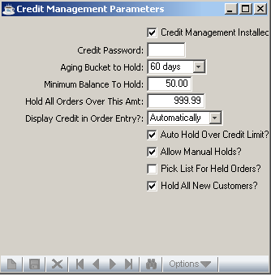

In the Credit Management Installed? field…
- Click the checkbox to indicate Yes to mention this option is installed
- Leave the checkbox blank to indicate No if the option is not installed

In the Credit Password field…
- Enter password, its length ranges from 1-6

In the Aging Bucket to Hold field …
- Select from the drop down menu, number of days to hold(30,60,90 or 120 days)

In the Minimum Balance to Hold field…
- Enter the amount to be set as the minimum balance

In the Hold All Orders Over This Amt field…
- Enter the amount to set as the limit for orders

In the Display Credit in Order Entry field …
- Select Automatically, to automatically display credit in order entry, every time.
- Select On Request, to display credit in order entry on customer’s request.
- Select Never, to disable the display of credit in order entry.

In the Auto Hold Over Credit Limit? field…
- Click the Checkbox to indicate Yes to auto check credit limit on every new order.
- Leave the Checkbox blank to indicate No

In the Allow Manual Holds? field…
- Click the Check Box to indicate Yes to check credit limit manually
- Leave the Check Box blank to indicate No

In the Pick List for Held Orders? field…
- Click the Checkbox to indicate Yes to list out the credit held orders
- Leave the Checkbox blank to indicate No

In the Hold All New Customers ? field…
- Click the Checkbox to indicate Yes to set the credit limit for every new customers
- Leave the Checkbox blank to indicate No

After entering all the fields in this screen click the save button

If you attempt to leave an unsaved data by clicking New or Close Window button, the module will issue a confirmation box as follows:

• Click Yes to save the current record and return to credit Management Parameter option.
- Click No to return to the credit Management Parameter option. without saving the current record.
- Click Cancel button to return to the credit Management Parameters Screen.

Accounts Receivable Utilities
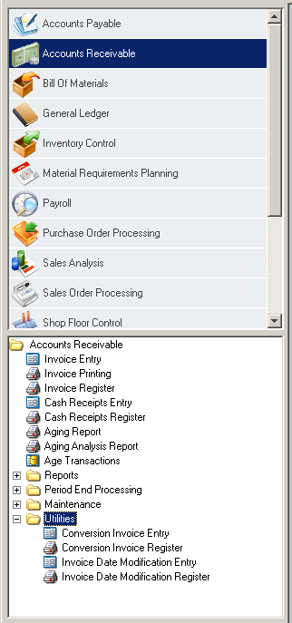

Function
The Accounts Receivable Utilities menu provides access to tasks used for special functions. The items on this menu should only be used after consultation with your dealer and accounting professional. Only operators with special permission (refer to User Maintenance) may access this menu.

n To access the Accounts Receivable Utilities menu...

Click the Utilities option after accessing Accounts Receivable.

About the AR Utilities Tasks
To access any task on this menu, click the appropriate options.

Conversion Invoice Entry
The Conversion Invoice Entry task creates summary invoice records that are posted to the customer’s account and, optionally, to the general ledger. These records represent open accounts receivable invoices.

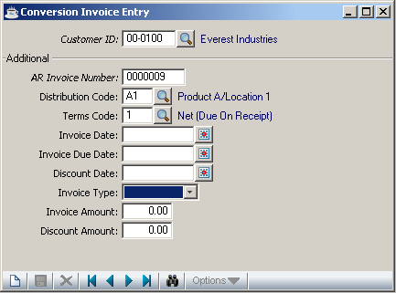

This task is used to enter invoices that existed prior to the installation of the Accounts Receivable module (Conversion Invoices). It may also be used to post after-the-fact invoices in systems where there is no Order/Invoice processing module installed.

NOTE: This task may also be used to modify, add, or delete finance charge records to the Finance Charge Register. It is recommended that regular conversion invoices and finance charges be entered in two separate batches to avoid confusion between the two processes.

In the Customer Number field...
• Enter a valid customer number.
• Click the find button to select from a list of valid customers

When the customer number already exists, the customer name is displayed. Otherwise you are prompted to enter another number.

In the Name field...
Display only. Shows the name associated with the customer number.

In the AR Invoice Number field...
• Enter a seven-digit invoice number.

NOTE: If the invoice is already in the module, you will not be able to enter the transaction. To adjust invoices, refer to Cash Receipts Entry or Simple Invoice Entry.

In the Distribution Code field...
• Enter a valid distribution code.
• Click the find button to select from a list of Distribution codes

The description of the code is displayed. The distribution code determines the general ledger account numbers for sales, accounts receivable and discounts when the invoice is updated and the update option is selected.

In the Terms Code field...
• Enter a valid terms code.
• Click the find button to select from a list of valid Terms codes

The description of the code is displayed. The terms code will determine the invoice due date and discount due date using the invoice date as a basis for calculation.

In the Invoice Date field...
• Enter the date that the invoice is to be posted to general ledger.
• Click the calendar button to set date

This date is used as the reference point by the terms code to determine the due date and discount due date of the invoice. These dates are displayed and may be overridden as needed.

Example
When the invoice date is 10/10/04 and the terms code is 2% 10 NET 30, then the discount is due 10/20/04 and the invoice is due 11/09/04.

In the Invoice Due Date field...
• Enter the due date of the net invoice.
• Click the calendar button to set date

In the Discount field...
• Enter the due date of the net invoice.
• Click the calendar button to set date

Example
When the discount due date is 10/20/04, the customer may receive a discount (if applicable) by paying on or before this date.

In the Invoice Type field( Drop down menu)...
• Select Adjustment for adjustment transaction.
• Select Cash for cash transaction.
• Select Invoice for adjustment transaction.
• Select Sale for sale transaction.
• Select Void, if the other four types cannot be used.

In the Amount field...
• Enter the total amount of the invoice.

In the Discount field...
• Enter the amount of discount available on this invoice.

NOTE: Discounts are recorded as memo amounts only at this point. They are not posted to the general ledger until after they are actually taken. This is determined during cash receipts processing.

When all the fields are entered/modified, click the save button . If you uses the new/clear form button without saving the current record the following prompt is displayed

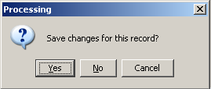

- Click Yes to save the current record and cursor focuses on the customer_id field for the next new entry
- Click No to discard the current record and the curson focuses on the customer_id field for the next new entry
- Click Cancel to retain the record as it is.

Conversion Invoice Register
The Conversion Invoice Register task prints a report of all conversion invoices prior to making postings to the customers’ accounts. Conversion invoices may be optionally posted to the general ledger.

The following prompt is issued:

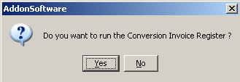

- Click Yes to run the Conversion invoice register

- Click No to return to the menu. You may then re-enter the Conversion Invoice Entry task to make any changes required and print the register later.

The following prompt is issued when you click Yes to the Run Conversion Invoice Register prompt:

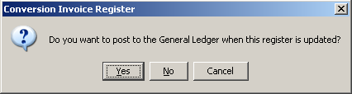

• Click Yes to post the conversion invoices to the general ledger using the distribution codes associated with each invoice.
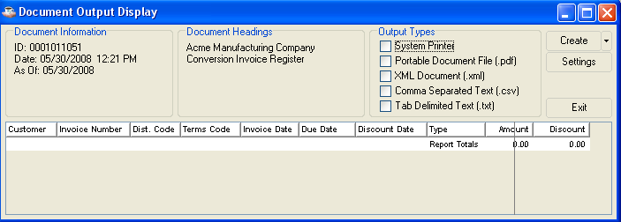
• Click No if you do not want to post transactions to the general ledger, but still have them added to the accounts receivable open item file.
• Click Cancel to return to the menu without updating anything.

NOTE: The primary purpose of not updating to general ledger is for conversion purposes when you are entering invoices into the open invoice file and these invoices have already been recorded in the general ledger. However for daily processing, if you have a live general ledger system, you should always answer Yes to avoid having your accounts receivable general ledger control account(s) out of balance with the accounts receivable subsidiary ledger.

When exiting the above Document Output Display another prompt is issued:

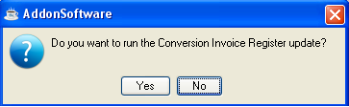

• Click Yes to update the register.

- Click No to return to the menu without updating.

Updating
The conversion invoices are posted to the customer accounts. When you selected to post to general ledger, the amount of the invoice is debited to the accounts receivable account and credited to the revenue account associated with the invoice distribution code.

Invoice Date Modification Entry
The Invoice Date Modification Entry task allows modification of terms code, invoice date, due date and discount date for customer open invoices.

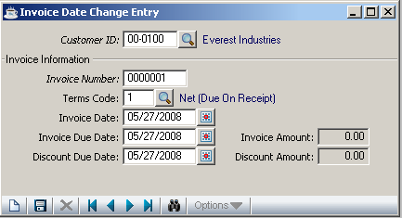

NOTE: This task will modify the invoice date, due date, and discount due, or any combination of the three. It does not, however, modify dates in Invoice History Inquiries. Care should be taken when using this task that associated general ledger transactions be adjusted as well.

In the Customer Number field...
• Enter a valid customer number.
• Click the find button to select from a list of valid customer numbers

When the customer number already exists, the customer name is displayed. Otherwise, you are prompted with this messge and the cursor return to Customer ID field.

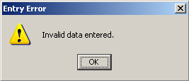

In the Name field...
Display only. Shows the name associated with the customer number.

In the Invoice Number field...
• Enter a seven-digit invoice number.

NOTE: If the invoice is already in the module, you will not be able to enter the transaction. To adjust invoices, refer to Cash Receipts Entry or Simple Invoice Entry.

In the Terms Code field...
- Enter a valid Term code
- Click the find button to select from a list of valid Terms codes.

The description of the code is displayed. The terms code will determine the invoice due date and discount due date using the invoice date as a basis for calculation.

In the Invoice Date field...
- Enter the date that the invoice is to be posted to general ledger.
- Click the calendar button to set date

This date is used as the reference point by the terms code to determine the due date and discount due date of the invoice. These dates are displayed and may be overridden if desired.

Example
When the invoice date is 10/10/04 and the terms code is 2% 10 NET 30, the discount is due 10/20/04 and the invoice is due 11/09/04.

In the Invoice Due Date field...
• Enter the date that the net invoice is due.
• Click the calendar button to set date

In the Discount Due Date field...
• Enter the date that a discount is given if payment is received.
• Click the calendar button to set date

Example
When the discount due date is 10/20/04, the customer may receive a discount (if applicable) by paying on or before this date.

When all the fields are entered/modified, click the save button . If you uses the new/clear form button without saving the current record the following prompt is displayed

- Click Yes to save the current record and cursor focuses on the customer_id field for the next new entry
- Click No to discard the current record and the curson focuses on the customer_id field for the next new entry
- Click Cancel to retain the record as it is.

Invoice Date Modification Register
The Invoice Date Modification Register task prints a report of all modified invoices prior to making the adjustments to the accounts receivable open invoice file.

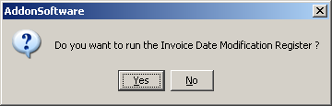

- Click Yes to print the Invoice Date Modification Register
- Click No to return to utilities menu

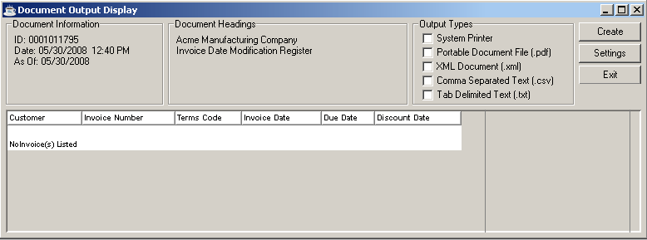

After the report is being displayed the system prompts you with the following screen

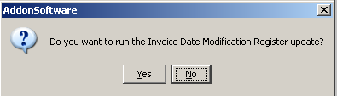

- Click Yes to update Invoioce Date Modification Register
- Click No to return to utilities menu

Updating
The modifications are made to the open invoices as the invoice number is displayed on the screen. General Ledger postings are not made as part of the update. After the Invoice Date Modification Register is updated, the system prompts you with this screen

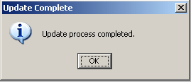

Click OK to return to the utilities menu

